CAUTION: THESE OPERATING INSTRUCTIONS MUST BE STRICTLY FOLLOWED IN ORDER TO ENSURE OPERATOR SAFETY AND ACCURATE TESTING RESULTS. THESE INSTRUCTIONS SHOULD BE READ COMPLETELY BEFORE INSTALLING OR OPERATING THIS EQUIPMENT.
Caution: Keep hands and other objects clear of the test area or moving components when testing is in progress

Disclaimer: If the English Manual or accompanying English instructions are translated to another language, the English Manual takes precedent.
Ampac International, Inc. is not responsible for errors in language translation.

The specifications and information contained herein are subject to change without notice. Warranty information is provided in a separate letter.

The information contained in this document is the property of Ampac International, Inc.
This document is provided solely for the purpose of assisting operating and maintenance personnel in the correct use of the test equipment described in this document. This document is provided on the express condition that neither the document, software, nor
the information contained therein shall be disclosed to others or used for any other purpose.

The information presented in this document is believed to be complete and accurate. However, in the absence of an express written agreement to the contrary, Ampac International, Inc. assumes no liability for its completeness or accuracy, nor for any damages of any kind whatsoever which may arise from the use of the information.

We strive to make our equipment as resilient as possible for years of reliable service.
We have included many types of protection devices and filters for the continued protection of our equipment.
However, we cannot guarantee or warranty any machine that has been damaged due to bad power, such as brownouts, spikes, excessive EMI or other electrical power noise.

For proper operation of the test equipment, you must supply “Clean Power”.
The term “Clean Power” can include supplying the correct voltage, frequency, phase,
and good electrical grounding. This also means limiting the harmonic distortion and noise to levels that meet international guidelines. The input power must be as close to a sinusoidal waveform as possible.
This is especially important in environments that use Variable Frequency Drives.
Variable Frequency Drives can introduce noise, harmonic distortion, voltage fluctuations, etc., that can damage power supplies and other sensitive electronic components.

Contents
Page

1.0 Description 1
2.0 Specifications: IEC Incline Plane Static (CoF) Specifications 2
3.0 Incline Plane Static CoF Operating Instructions 3
3.1 Selecting Test Load (L) 4
3.2 Static CoF setup for round wire 0.05 to 2 mm 4
3.2.1 Loading Round Wire Specimen on the Load Block 4
3.2.2 Loading Round Wire Specimen on the Test Bed 5
3.2.3 Placing the Load Block onto the Test Bed 6
3.2.4 Start Static CoF Test 7
3.3 Static CoF setup for large round and rectangular wire 8
3.3.1 Loading large round/flat wire on the Load Block 8
4.0 Menu Screen 10
5.0Calibration 12
5.0 Maintenance 12
6.0 Parts List 12
Appendix A 13

Copyright © 2023
By
Ampac International, Inc.
1. 0 Description

The Nova+ 923 Incline Plane Static Coefficient of Friction Tester performs the Static Coefficient of Friction (CoF) according to IEC 60851-3 specification. The tester determines the Incline Plane Static CoF of film insulated round magnet wire for sizes:
Standard configuration of the incline plane platform: 0.05 - 1.6mm
Option: large round wire over 1.6 mm up to 6 mm
rectangular wire up to 6 x 20 mm.

The tester is of a modular design and are comprised of 2 sections:
1. Control Chassis (run on input power of 100 V ac to 240 V ac)
2. Incline Plane Static CoF test assembly

Figure 1 shows the external component layout of the test equipment.
Incline Plane Static CoF Test Platform
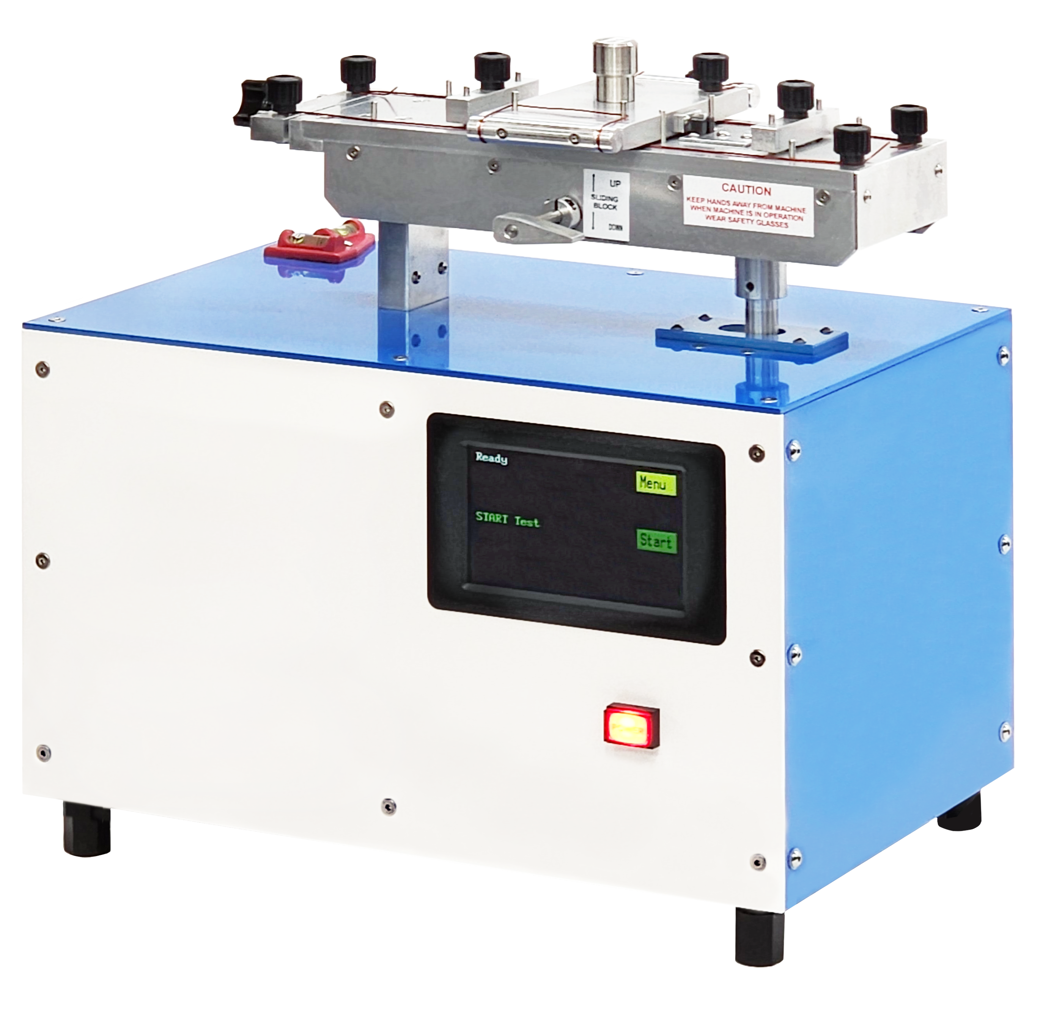

Touch Screen
LCD Display

Control Chassis

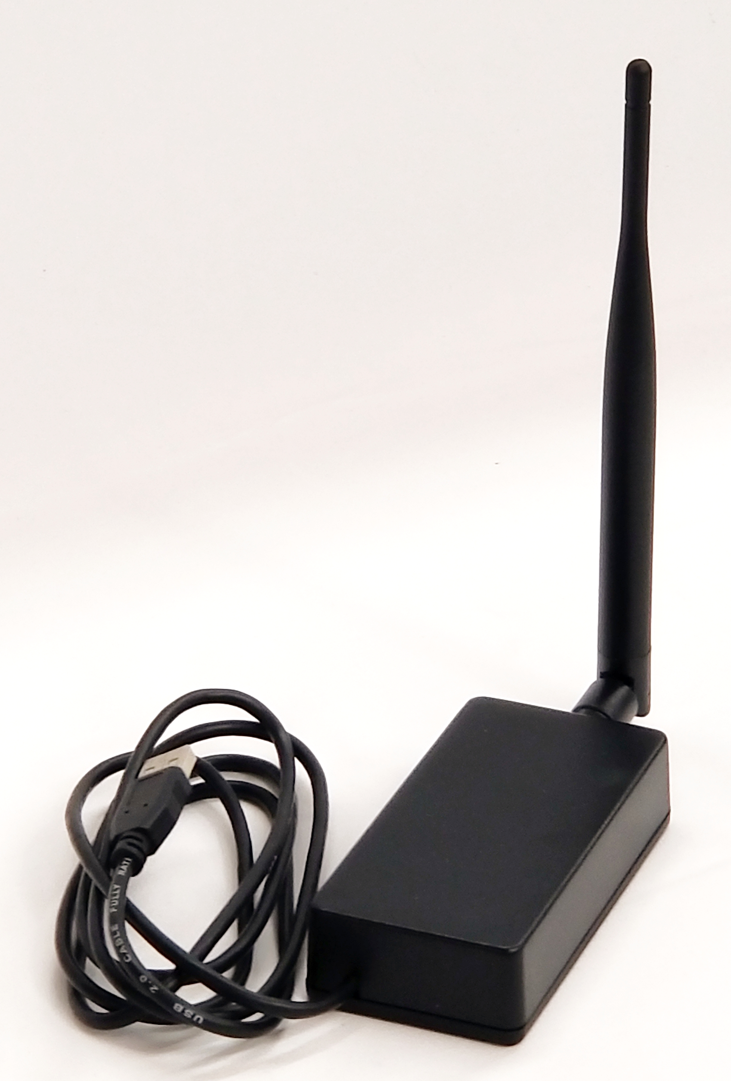

Figure 1: External Layout of the Nova+ 923

Figure 1A:
WR-100 Wireless Hub (Optional)

2.0 Specifications

The Nova+ 923 Incline Plane Static CoF Tester meets the IEC 60851-3 B.2 Test A Static CoF Test Method specification.

For the Incline Plane Static CoF test, The Load Block, Load (L), is applied to a test bed which holds the magnet wire samples in contact with each other. The static coefficient of friction (μ_{s}) is determined by measuring the inclining angle (α) of a plane (test bed) at precisely the moment when the moving block begins to slip on the track made from the wire specimen. The rate of the Test Bed inclination is approximately 1º per second.
μ_{s} = tan α
The static CoF test load (L) for various wire sizes is shown in Table 1 below:
Table 1

Test Load (L) Wire Size
50 g. 0.05 to 0.15 mm
500 g. > 0.15 mm

Note: Load Block weight for wire sizes larger than 1.6 mm is not specified. 500 g. is used.

Important Note:
It is important to understand the difference between Dynamic CoF and the IEC Static CoF:
1. In NEMA and IEC Dynamic CoF test, the dynamic CoF value is magnet wire enamel referenced to a curved sapphire surface of a given radius and smoothness.
2. In IEC Static CoF, the static CoF value is magnet wire on magnet wire.
Therefore, the NEMA / IEC Dynamic CoF value cannot be compared with the IEC Static CoF value. It is generally known that the Dynamic CoF value of a material reference to another material is less than that of the Static CoF value (same material reference). However, it has been observed that the NEMA / IEC Dynamic CoF may exceed that of the Static CoF. These differences in data may be due to many reasons, such as;
- the enamel surface may have defects such as blisters
- contamination by dusts particles
- wavy texture on the surface of the enamel from manufacturing process
- problems in the enameling process resulting in bare wire conductor, etc.
- section of the enamel may have insufficient lubricants
Since the wire is moving at a speed of 50 ft/min (15 m/min), the surface defects result in a higher force measured by the force load cell, resulting in a higher Dynamic CoF value.
This Dynamic CoF value may be higher than that of the IEC Static CoF value.

It is very important that when comparisons are made between Dynamic CoF and Static CoF, the test method are taken into account.
3.0 Incline Plane Static CoF Operating Instructions

The following picture shows the features of the Incline Plane Static CoF tester.
The main features are:
- Power switch
- Test Bed
- Moving Block (50 grams and 500 grams)
- Opto-Sensor
Large round and rectangular wire clamp
- Touch screen LCD Display
Large round wire
and rectangular wire clamp.
Installed with tester ordered for testing large round and rectangular wires
Opto-Sensor

- Bubble level
Moving Block
Small round wire clamping knobs
Test Bed

Wire specimen straightening block.
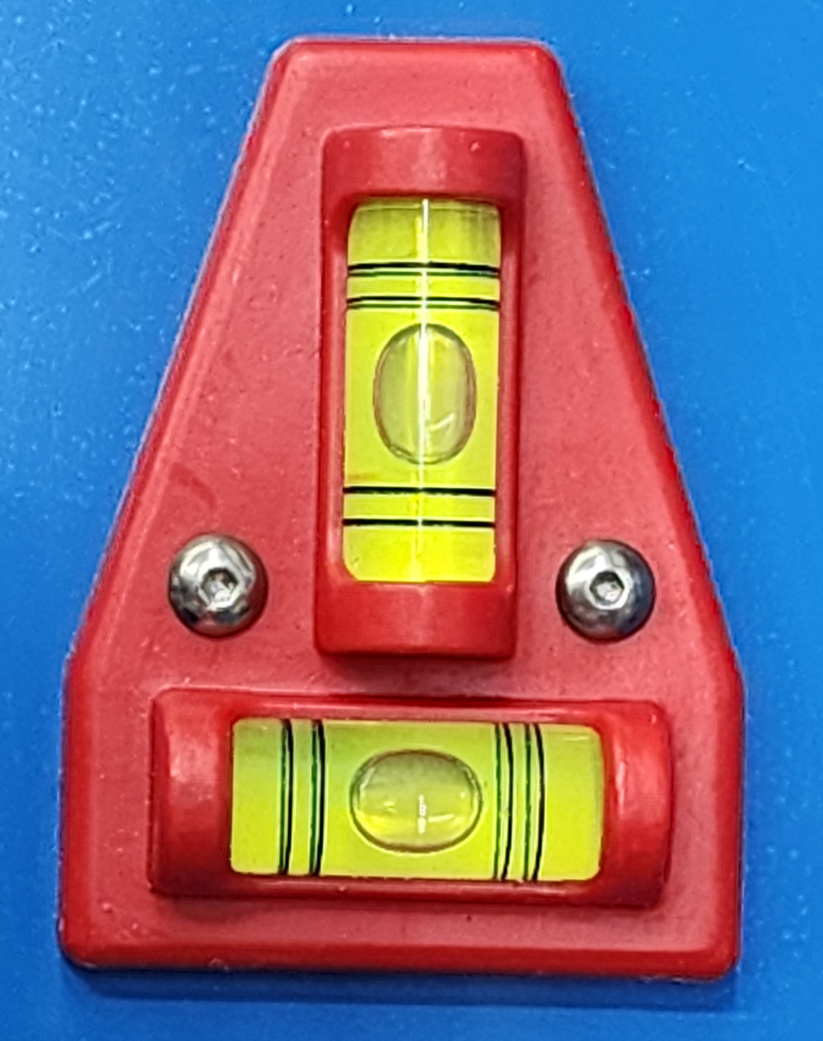
Small round wire clamping knobs

Moving Block
Lifting Lever

Bubble Level

LCD Display

Power switch

Incline Plane Level
Make sure the Incline Plane Chassis are level.
Adjust the chassis support feet (4 corners) to level the tester.
Figure 2:
Incline Plane setup shown with small round wire.

There are 2 procedures that need to be performed before the Incline Plane static CoF test can proceed:
1. Selecting the test load (L) for the wire size to be tested.
2. Loading the wire test specimens.

IMPORTANT FOR GOOD TEST RESULTS:
- Do not touch the section of the wire to be tested.
- Clean all surfaces where the wire makes contact regularly.
- Make sure the Incline Plane Platform/Chassis is level.
3.1 Selecting Test Load (L)

From Table 1 select the TEST LOAD (L) for the wire size to be tested.
Table 1
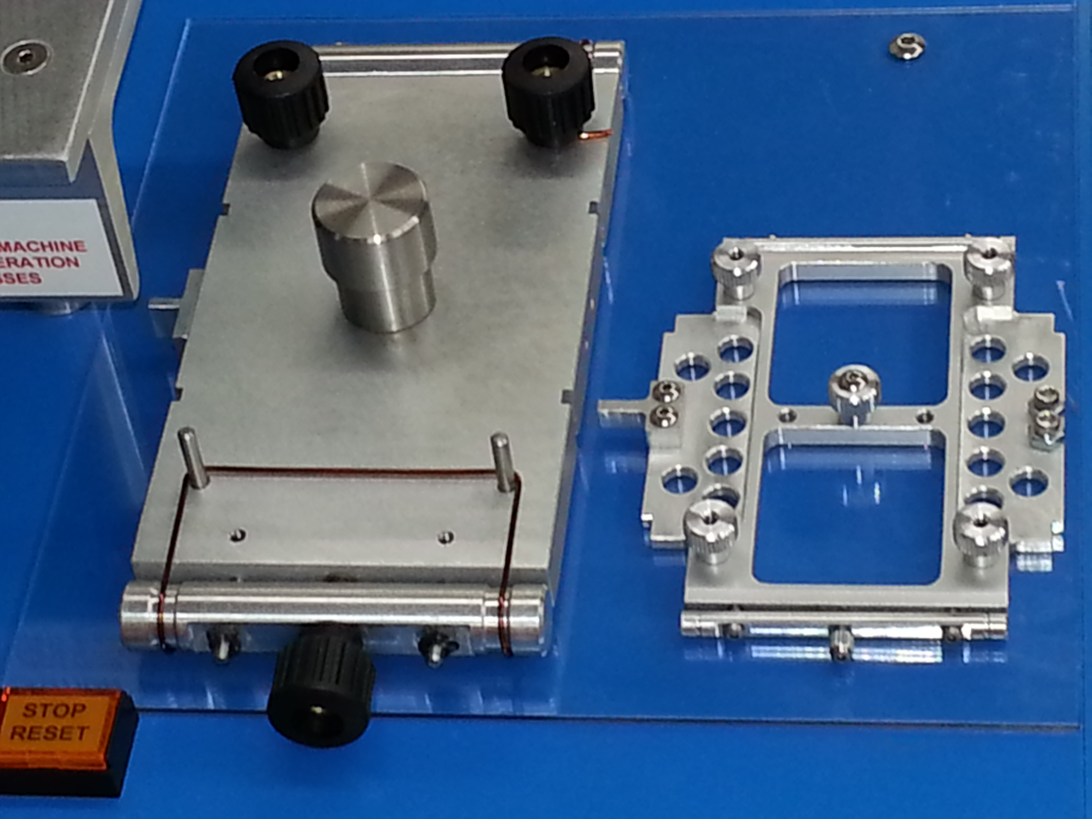

Test Load (L) Wire Size (AWG)
50 g. 0.05 mm to 0.15 mm
500 g. > 0.15 mm
50 g
500 g
50 g and 500 g Moving Blocks for round wires up to 1.6 mm
Figure 3

3.2 Static CoF setup for round wire 0.05 mm to 1.6 mm
3.2.1 Loading Round Wire Specimen on the Load Blocks

Round Wire from 0.05 mm to 1.6 mm:
The wire specimen is removed from the spool with as little bends and unevenness.
The wire specimen (23”/58 cm for 500 g LB and 2 pcs of 7”/18 cm for 50 g LB) is wound
on the Load Block, see diagram below.
The Load Block is equipped with tensioning device. The wire sample is tensioned slightly
to straighten the wire sample and to eliminate bends or bowing in the wire.
Turn knob clockwise to apply tension and straighten the wire
Wire is stretched to straighten wire
Turn knob clockwise to apply tension and straighten the wire
500 g.
Test Load Block
(Moving Block)
Turn knob clockwise to tighten
Opto Sensor Tab
50 g.
Test Load Block
(Moving Block)
Wire Tensioning Bar in the open position.
Tighten the Tensioning Knob until the wire is straighten.

Caution: Do not over stretch the wire

Wire Tensioning Bar in the
closed position
Bow in wire
Figure 4

3.2.2 Loading Round Wire Specimen on the Test Bed

Wire Path for wire sizes > 0.15 mm using 500 g. Moving Block
Note:
Two single wire can be used: Knob to A, B, to knob
Knob to C, D, to knob
Or
Single wire: Knob to A, B, D, C, to knob
Moving Block
Opto-Sensor Tab
Holding Clams for large round and rectangular wires not installed
Opto-Sensor
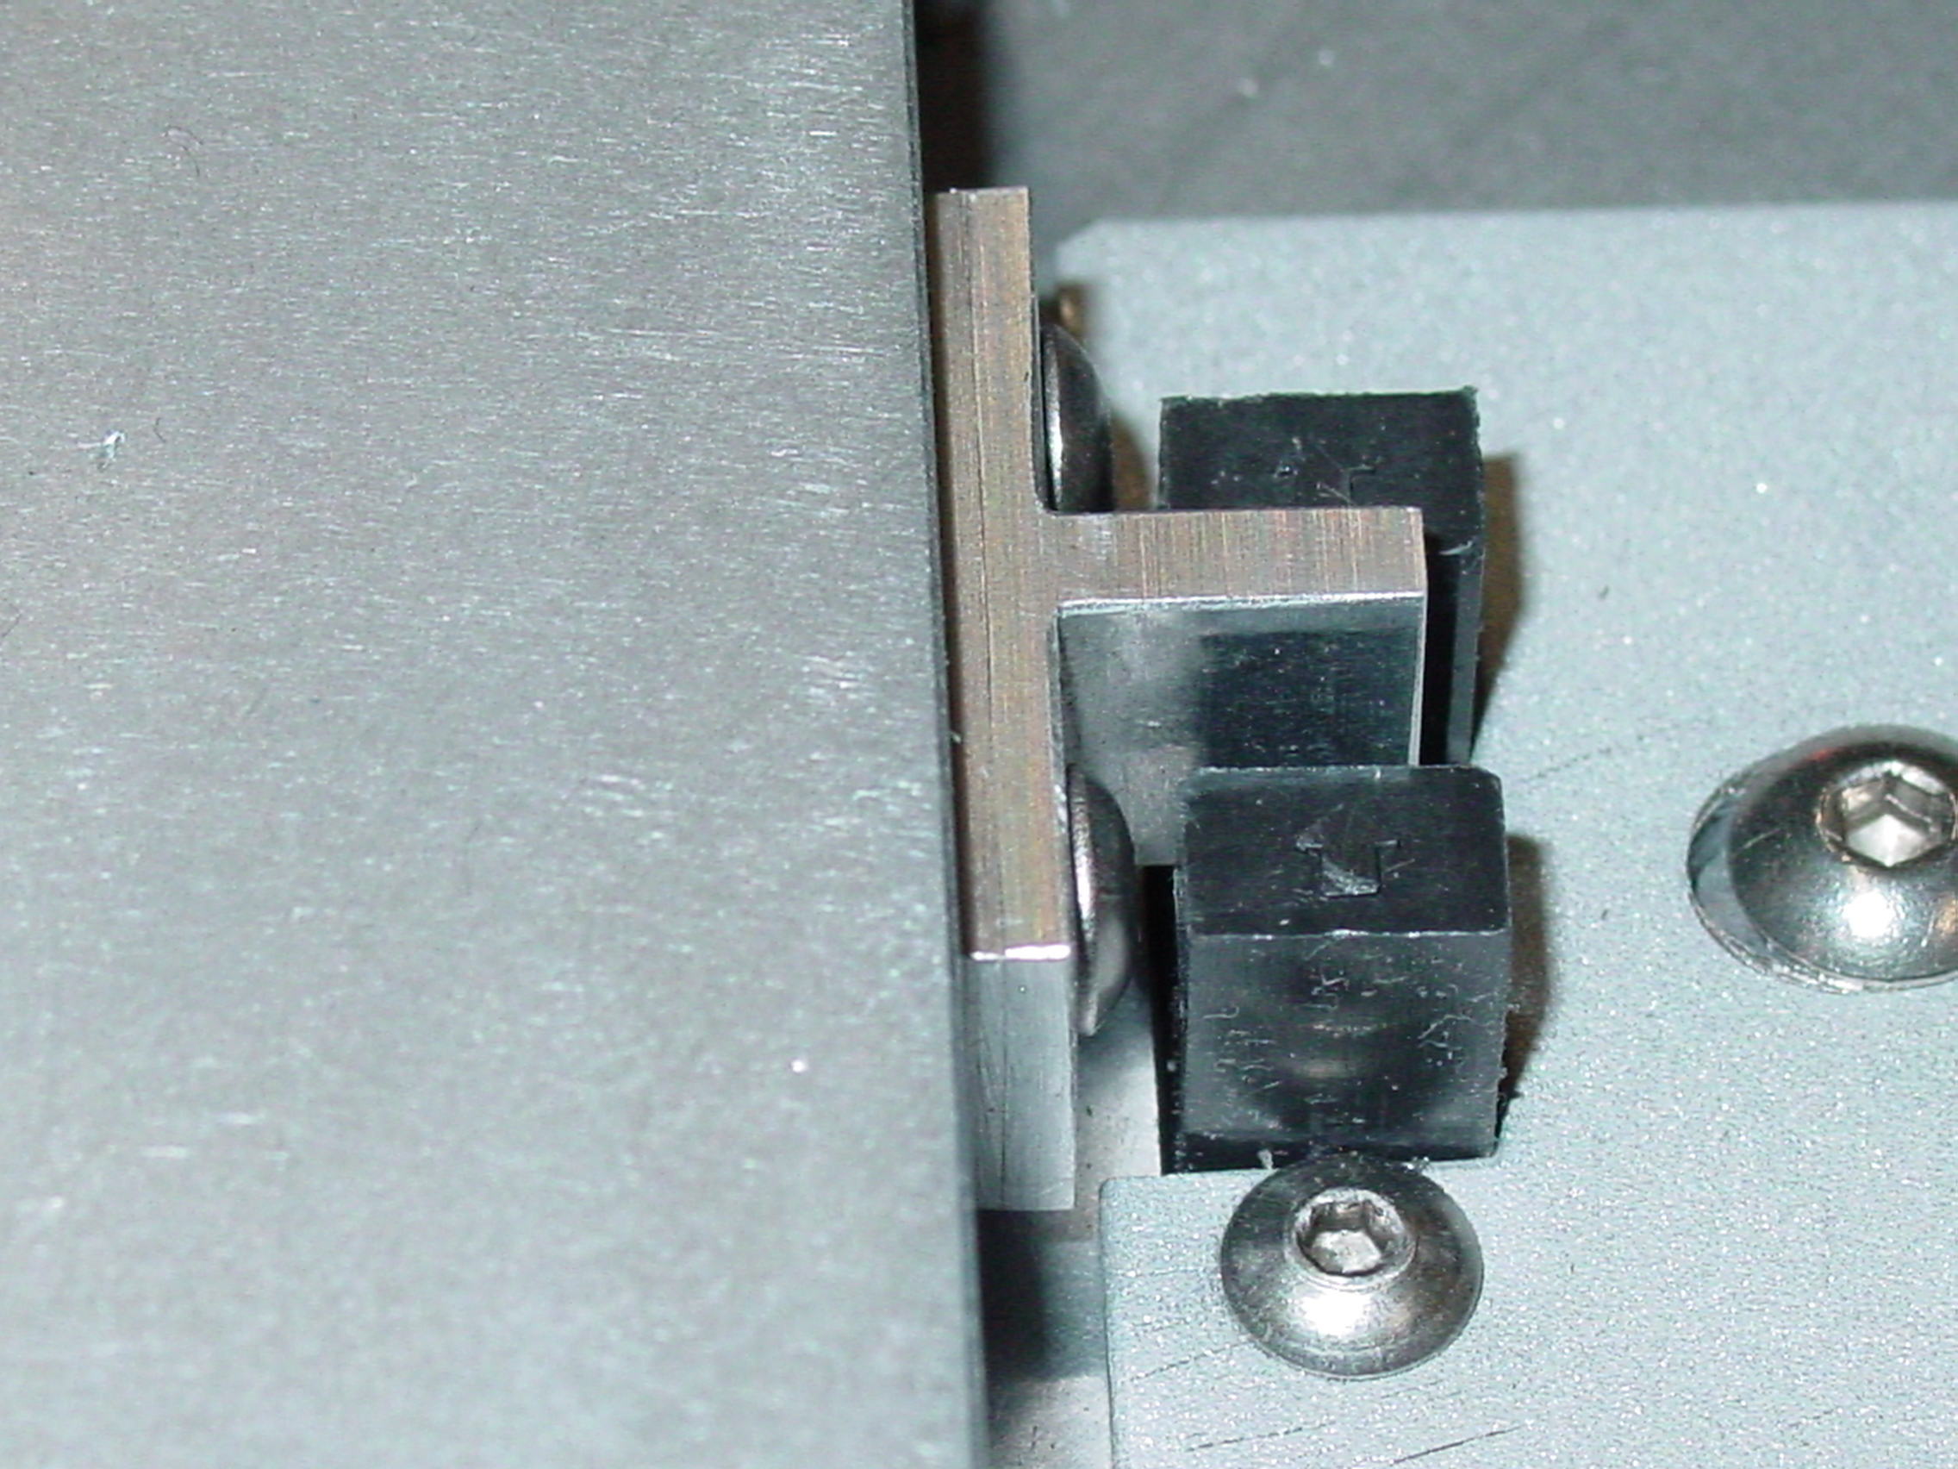

Figure 5B

Wire specimen clamping knobs
500 g.
Moving Block

Wire specimen
Optional wire path for single
length of wire.
From knob to A, B, D, C, to knob

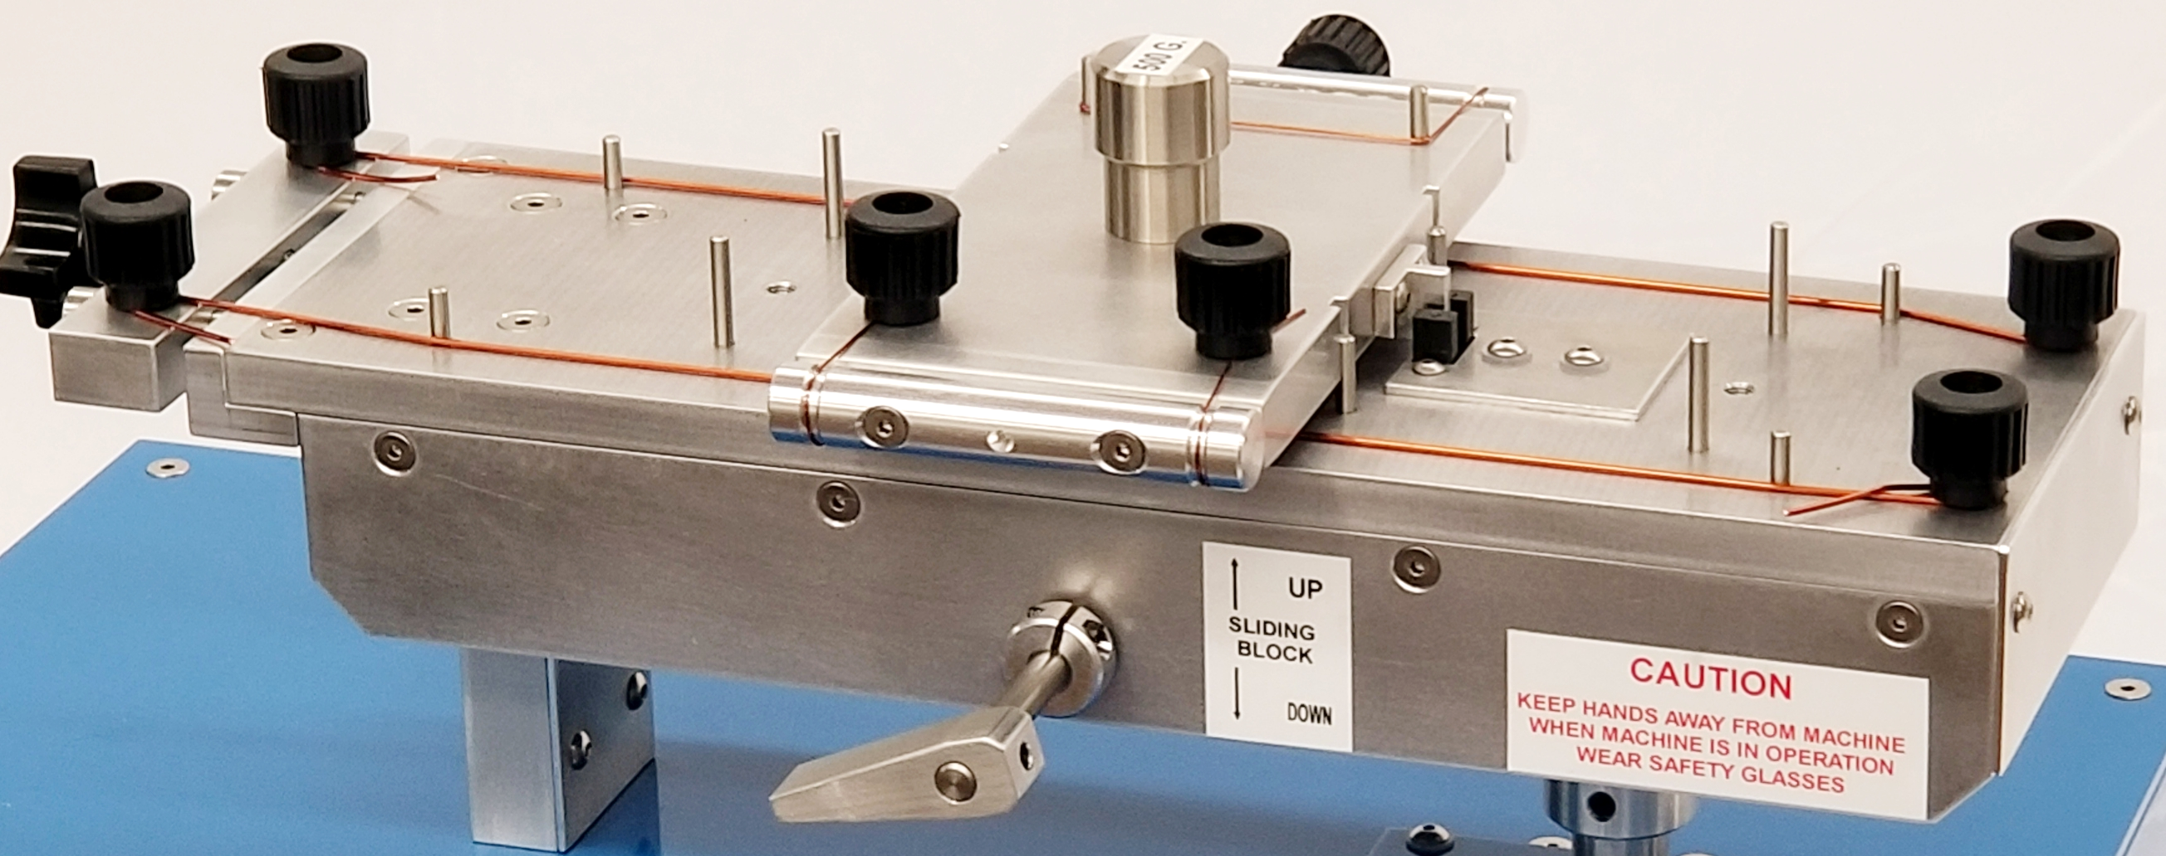
A

B
C

Wire specimen
D

Do not touch this section
of the wire samples

Figure 5A

Wire Path for wire sizes 0.05 mm to 0.15 mm using 50 g. Moving Block

Optional wire path for single
length of wire.
From knob to A, B, D, C, to knob

50 g. Moving Block
A
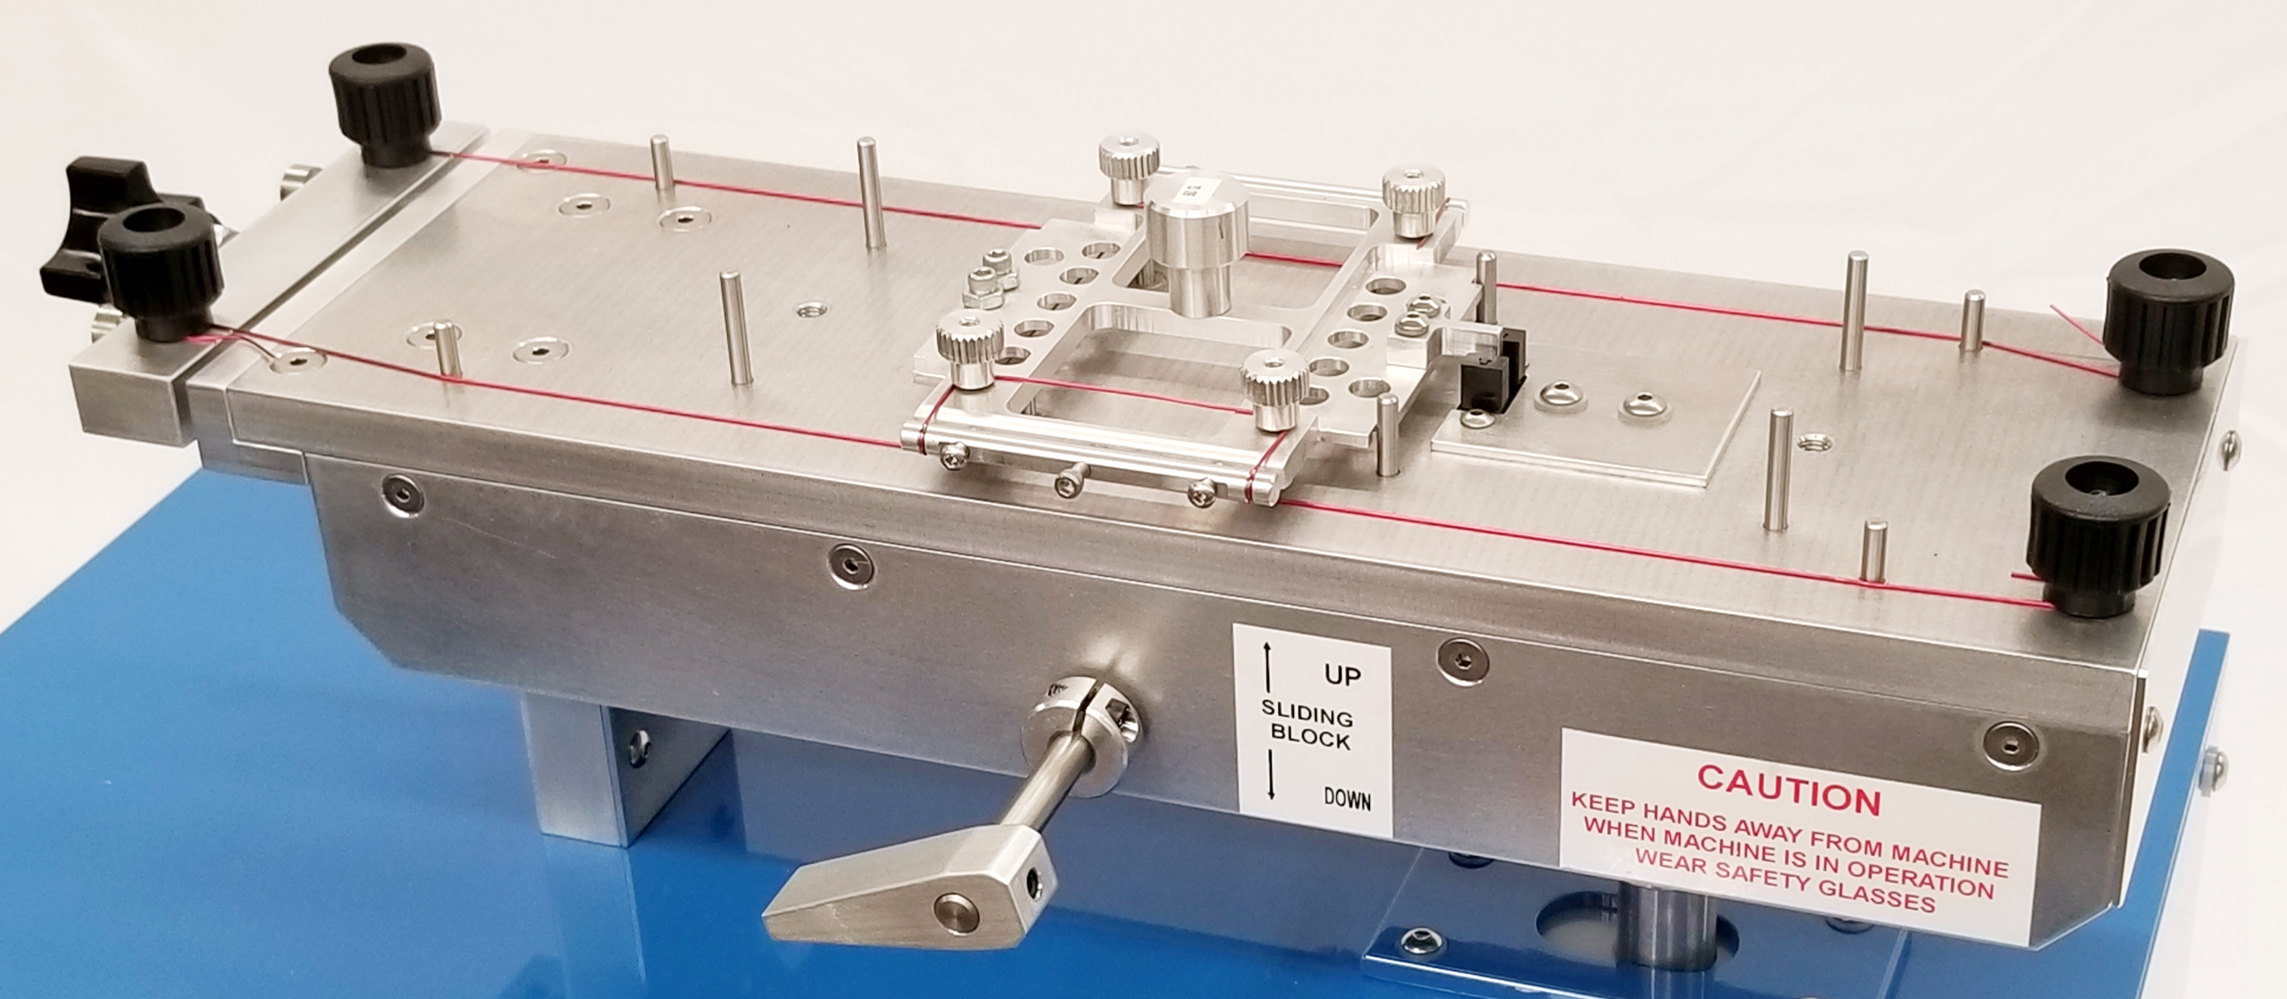
B
C
D1

D

Figure 6
3.2.3 Placing the Load Block onto the Test Bed
- Raise the Load Block Support Pins by turning the Load Block Lifting Lever counter- clockwise (figure 5 and 6).
- Gently place the Load Block onto the Load Block Support Pins.
The wire on the Load Block is at a right angle to the wire on the Test Bed.
The Load Block is now in place above the wires on the Test Bed.
- Slowly and carefully rotate the Lifting Lever clockwise to lower the Load Block.
- The START switch stopped blinking and stay lighted up.
Figure 7A
Load Block Lifting Lever in the Up position.
This raises up the Load Block Support Pins and keep the Load Block above the wire specimen on the test bed
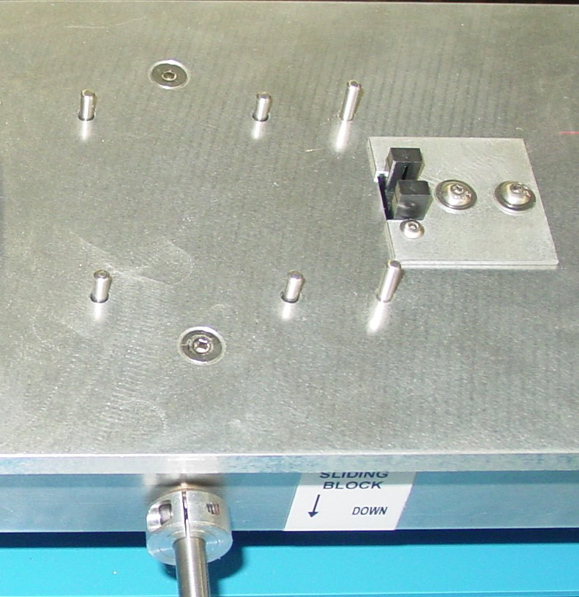
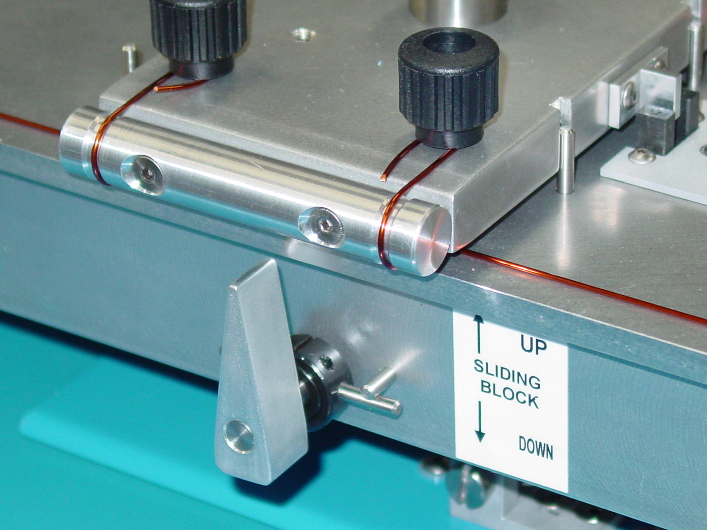

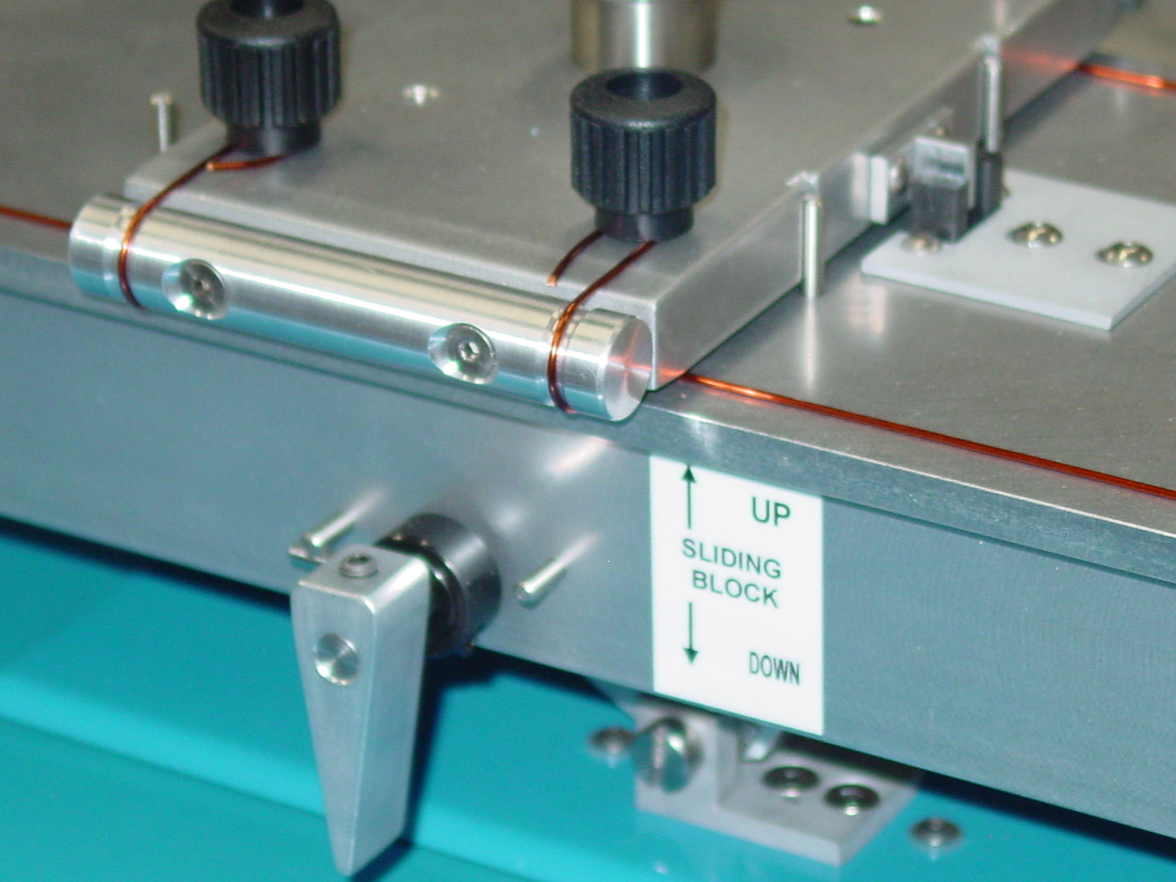
Load Block Guide Pins
Figure 7B
Load Block lifting lever
in the Down position. This lowers the Load Block onto the wire specimen on the test bed
Figure 7C:
Load Block
Support Pin
Load Block
Guide Pins

Indentation caused by the curvature of the wire specimen on the Moving Block being lowered down too quickly onto the wires on the Test Bed.
This indentation will occur on both the wire specimens mounted on the Test Bed and the Moving Block and result in higher Static CoF value.
It is very important to lower the Moving Block slowly and carefully.
This damage to the wire surface will occur more easily for finer size wires.

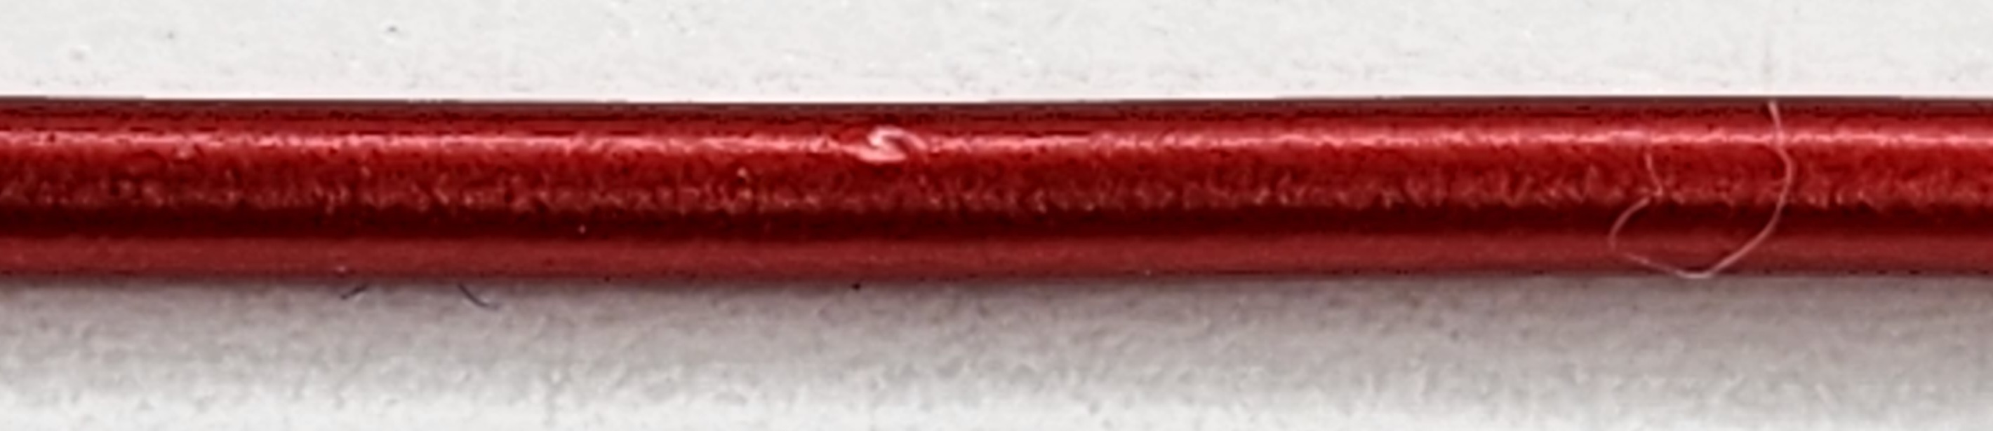

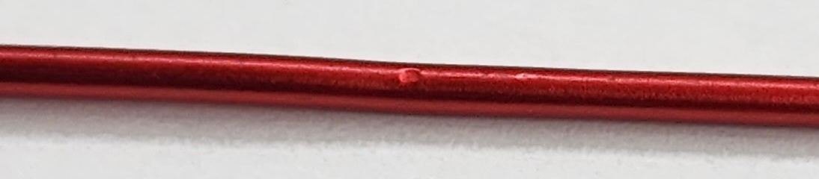

Figure 8:

3.2.4 Start Static CoF Test
- Press the POWER switch to turn on the tester.
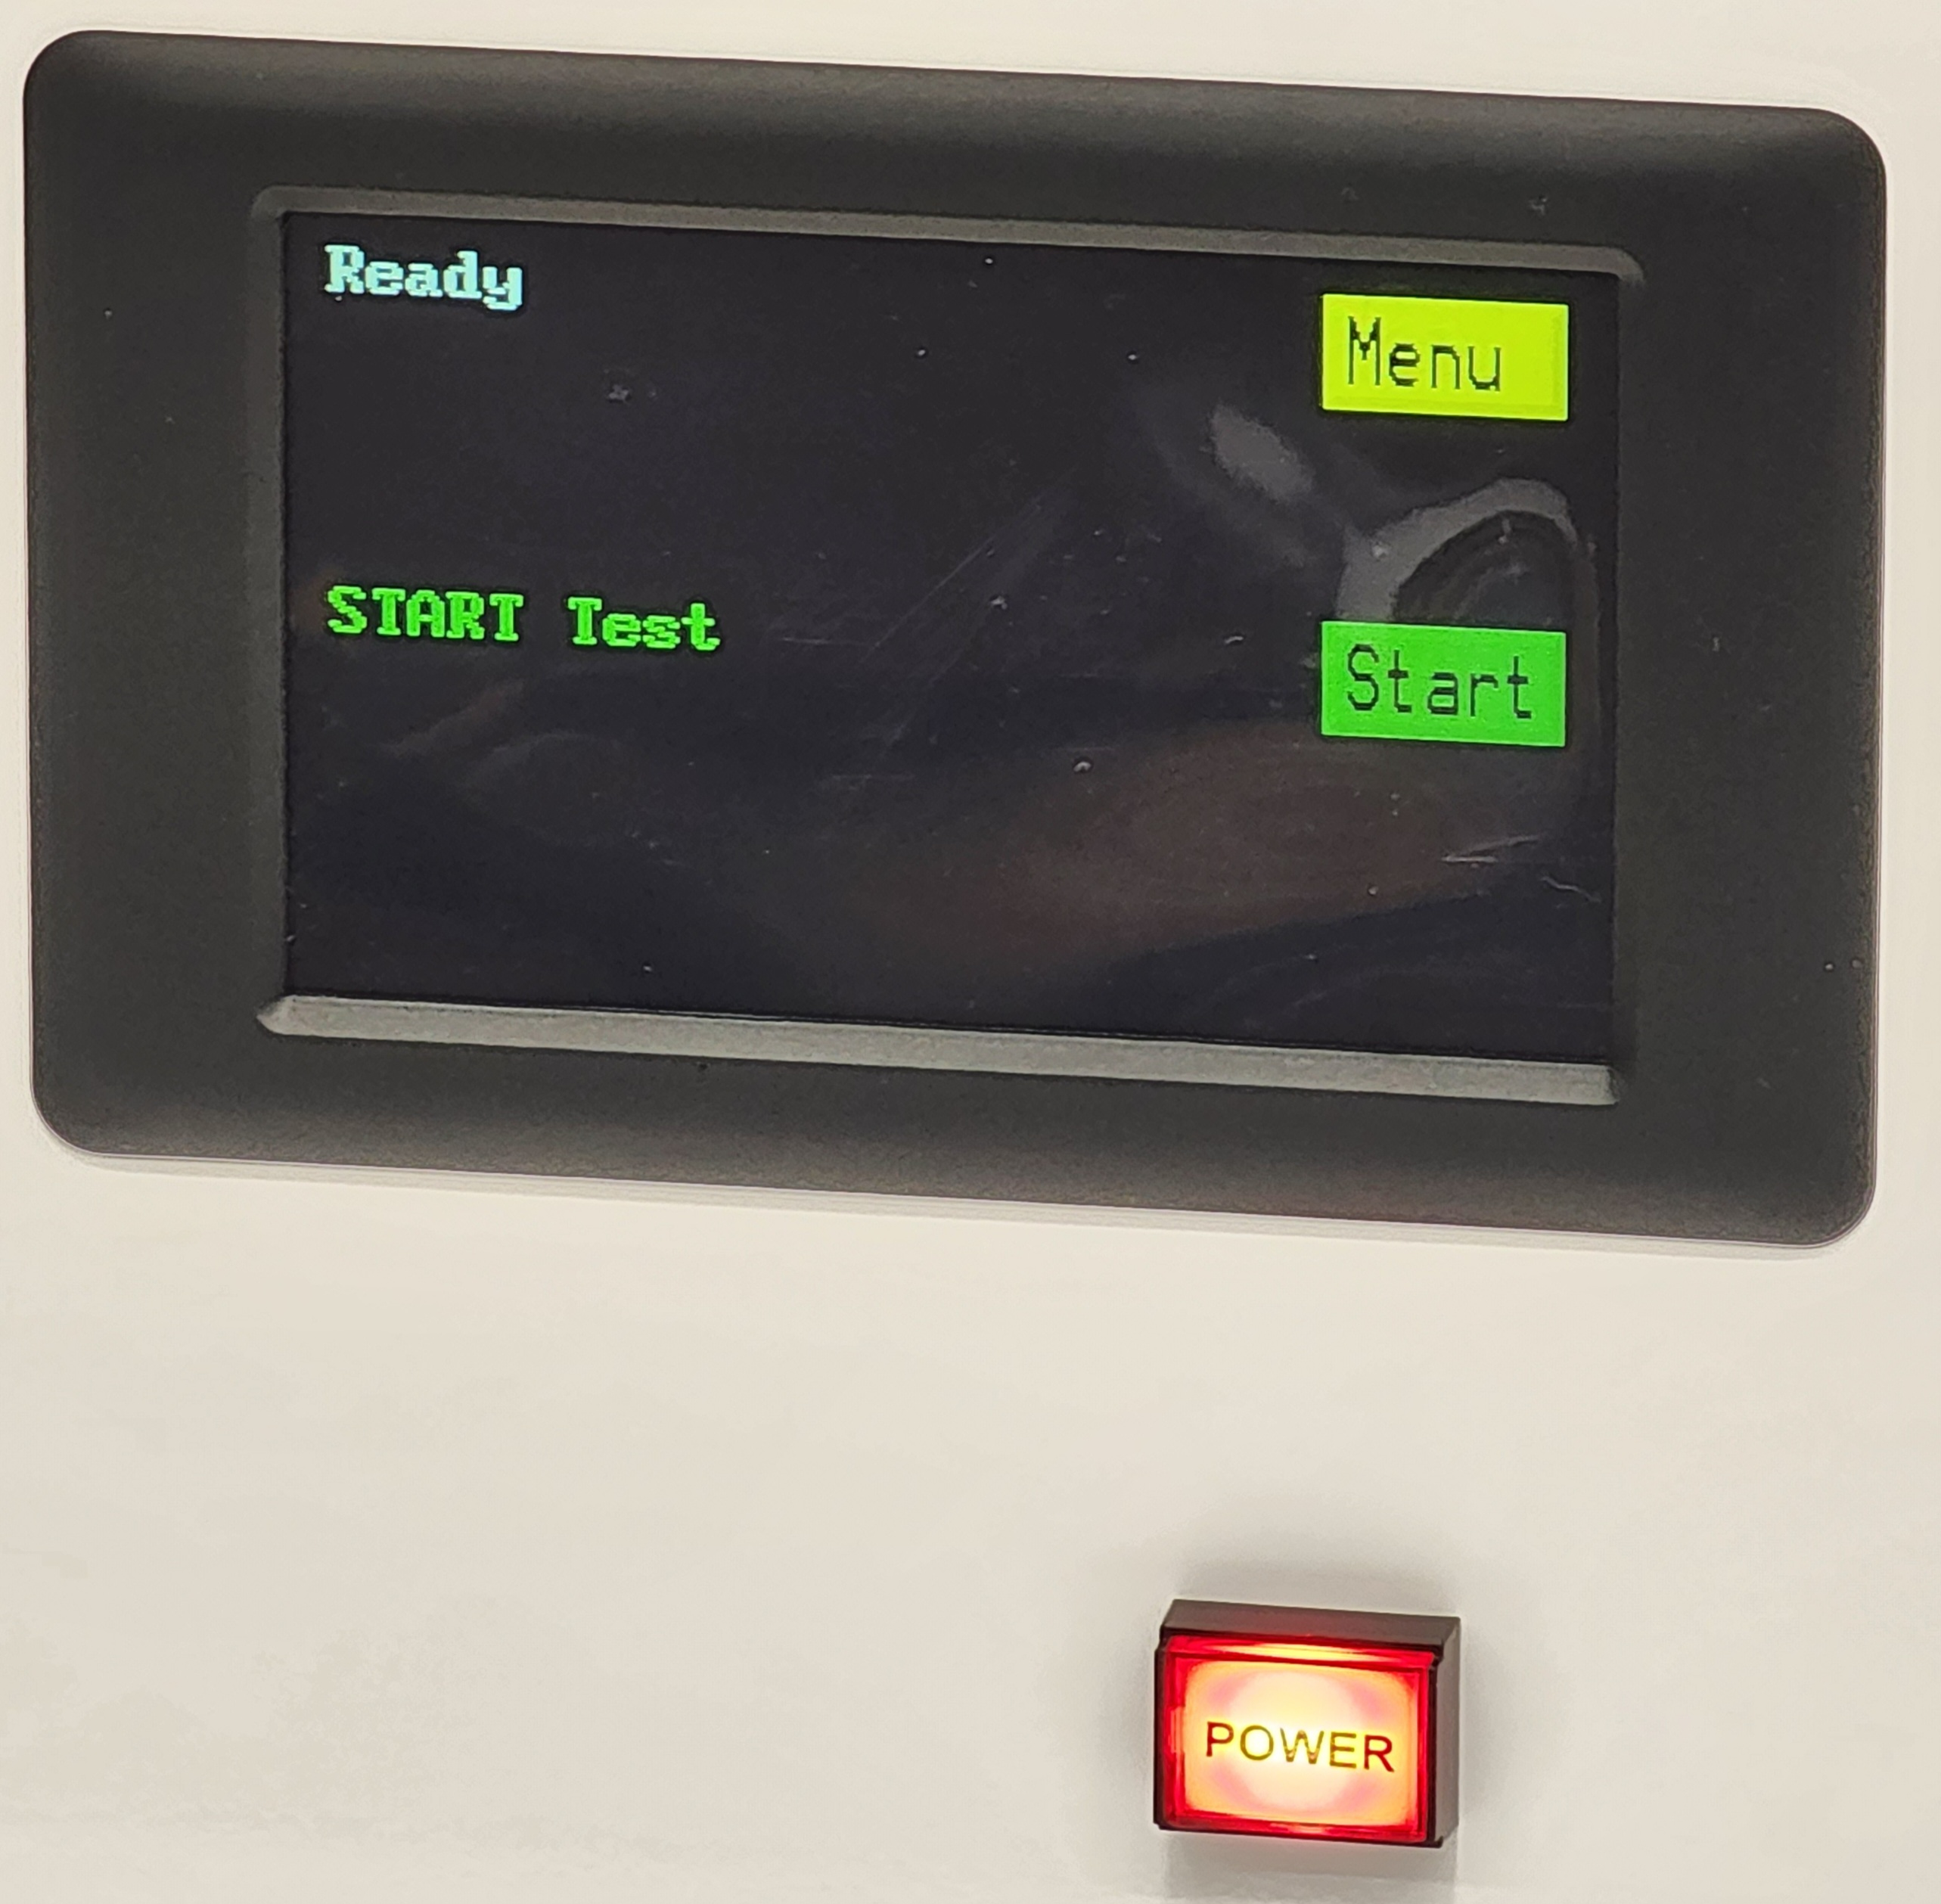
- Load the wire samples as indicated.
MENU
- Press the Start switch.
- The platform will start to rise.
START

- The Test Bed will stop once the Moving Block
Opto-Sensor Tab moves away from the
Opto-Sensor light path.
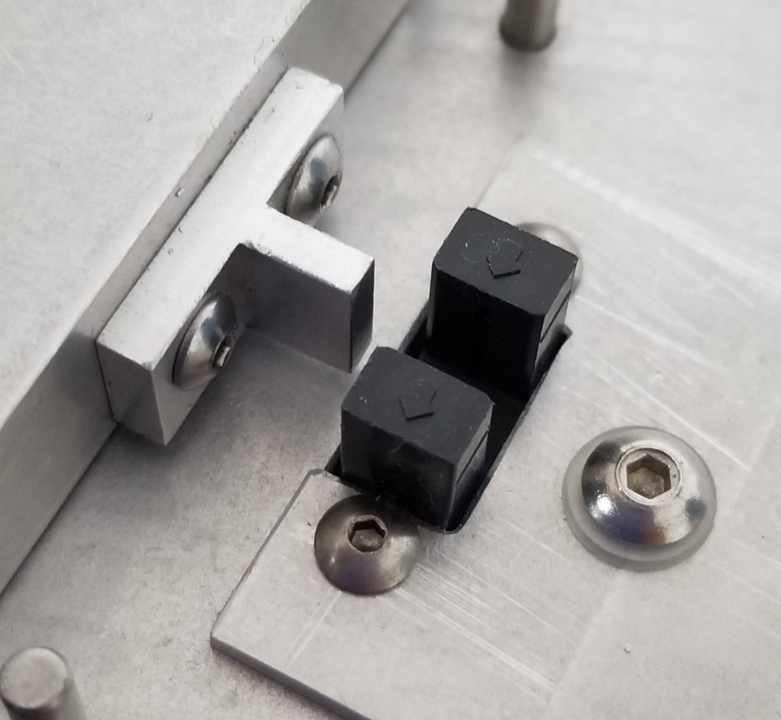

Power

Figure 9B

Figure 9A

A set of pins (or if the rectangular wire clamp if installed)
are located approximately 20 mm from the Moving Block
to stop the Moving Block once it slips.

- The Static CoF value, Tangent Ɵ, will be displayed on the LCD Display Screen.
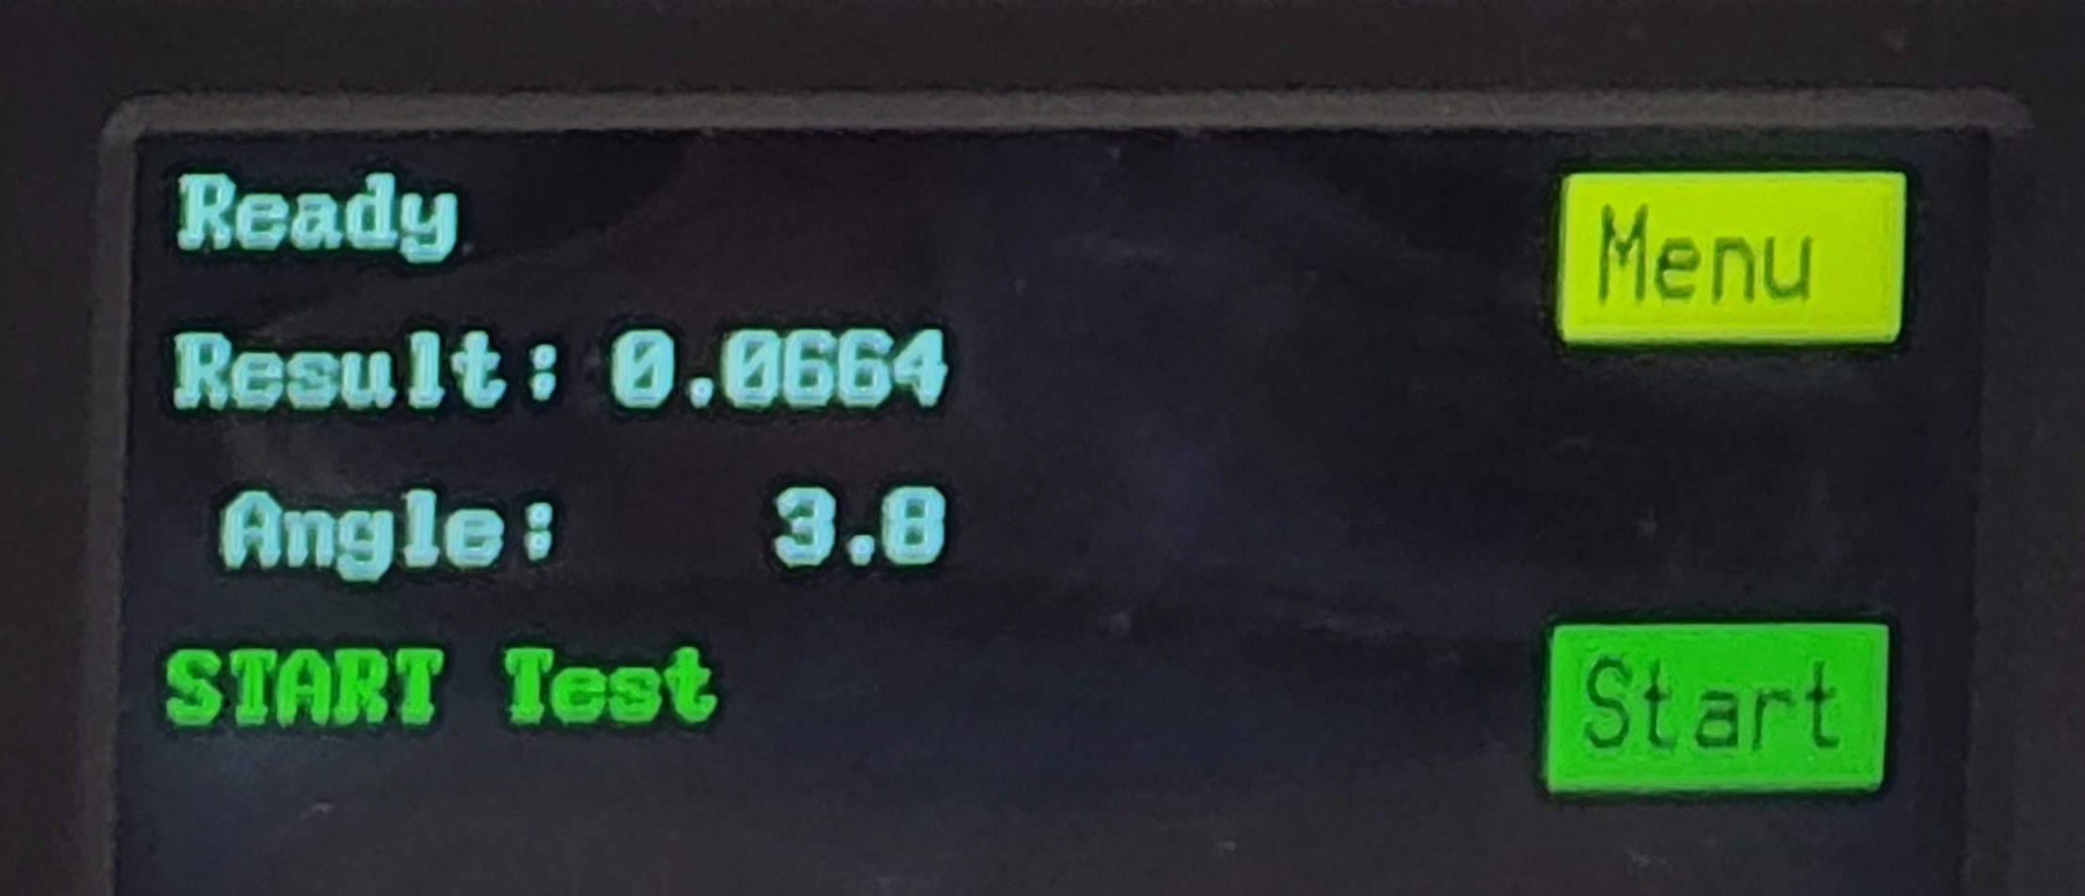

0.0664 = Static CoF value
3.8 = Static CoF angle = 3.8°

Figure 9C

- The Test Bed will automatically reset back to the horizontal (0º) position.
- It is now ready for another test.
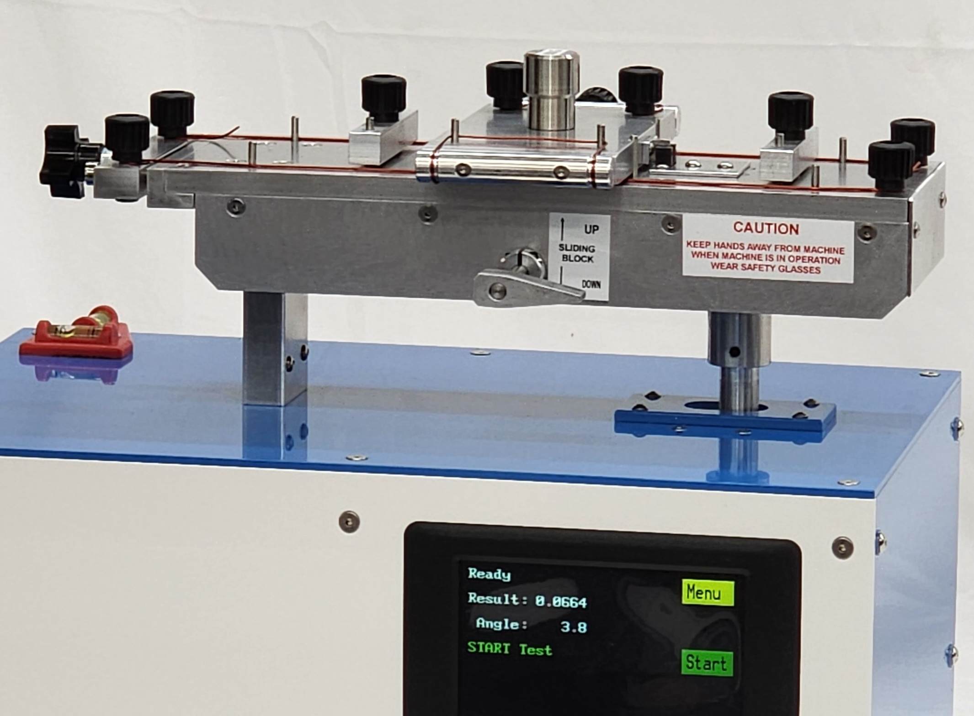
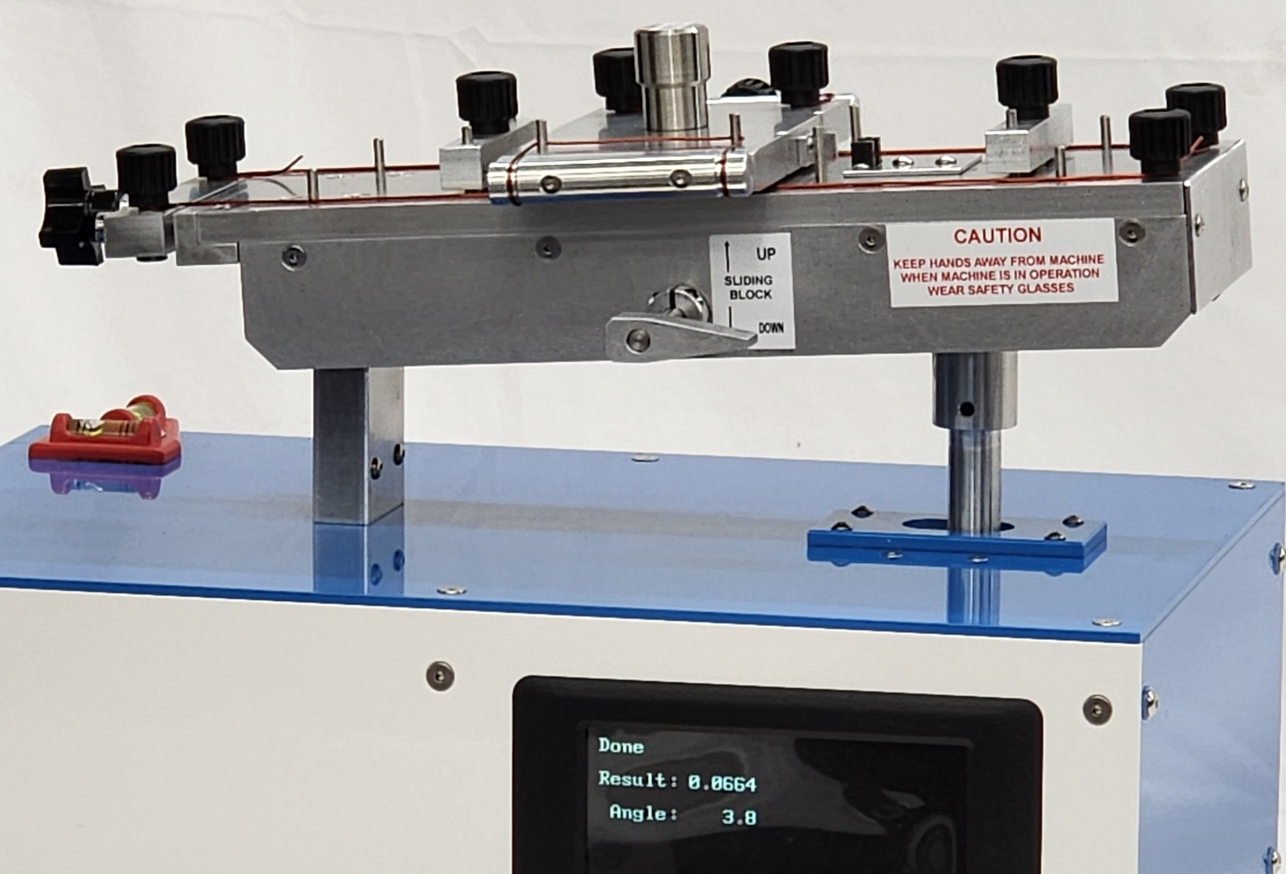
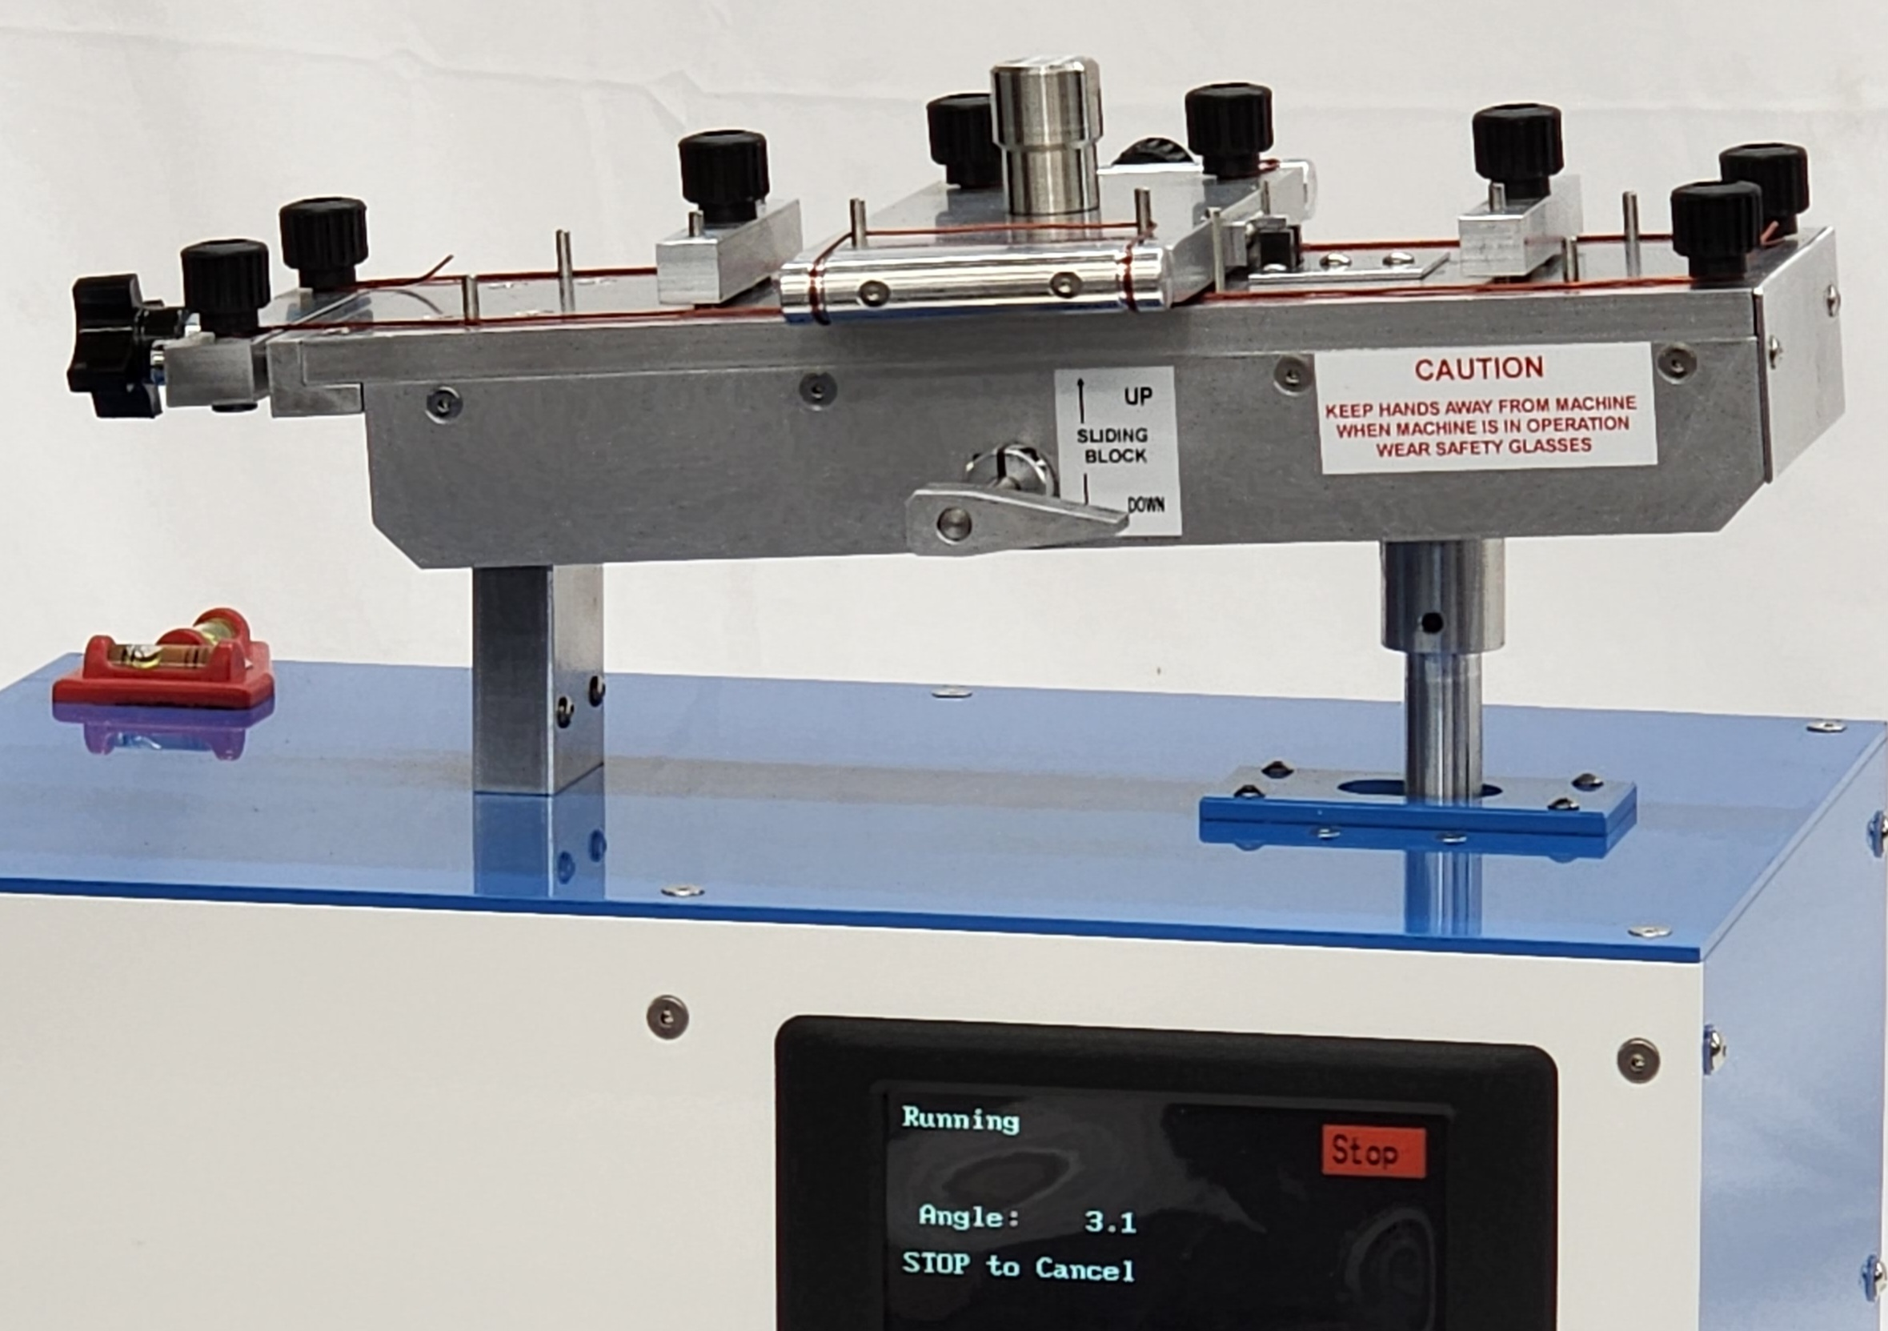

Figure 10C:
Test Bed in the raised position.
Load Block just moved and
Test Bed stop rising.
Static CoF value is displayed.
Figure 10B:
Test Bed
rising during test.
Press the STOP button to stop the test.
Figure 10A:
Test Bed in the reset position
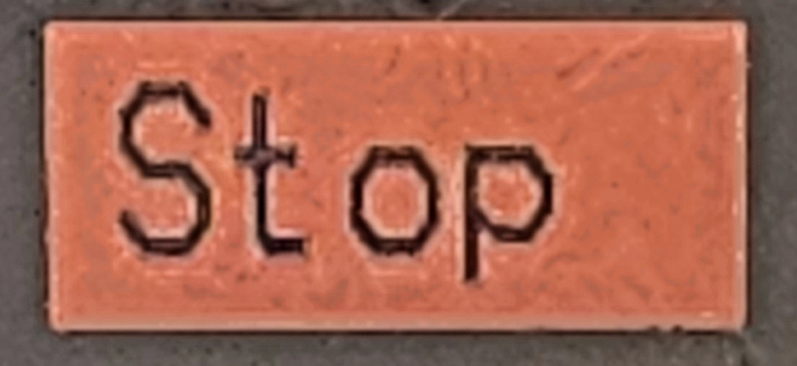

3.3 Incline Plane Static CoF setup for large round and rectangular wire

3.3.1 Loading large round and flat wire on the Load Block

Wire Holding Fixtures and Moving Block for:
Rectangular wires: up to 6 mm x 12 mm
Rectangular and large round wire holding clamps.
These clamps are only installed when rectangular wire test function is ordered.
Large round wires: up to 6 mm diameter

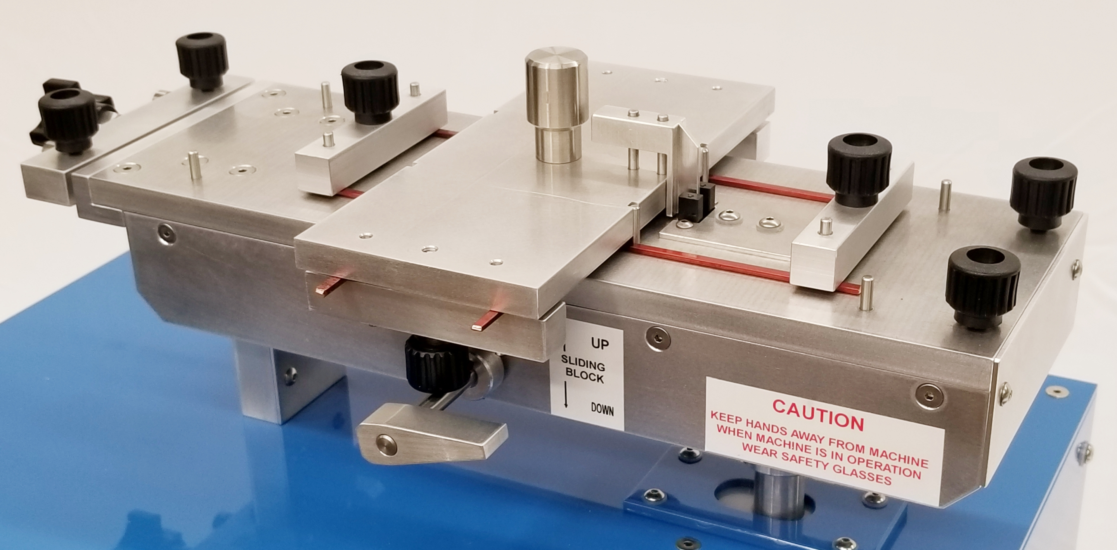

Figure 10

Large round and flat wire:
- The Test Bed should be in the Reset position.
- The wire specimen is removed from the spool with as little bends and unevenness.
- The wire specimen is then elongated by 1% to 2 % using an elongation device.
- Place the straightened wire (7”/ 18 cm) on the Load Block as shown in Figure 11.
- Clamp down on the 2 wires with the wire clamps.
- Place the straightened wire (9” / 23 cm) on the Test Bed as shown in Figure 10.
- Likely clamp down on the 2 wires with the wire clamps.
9” (23 cm)
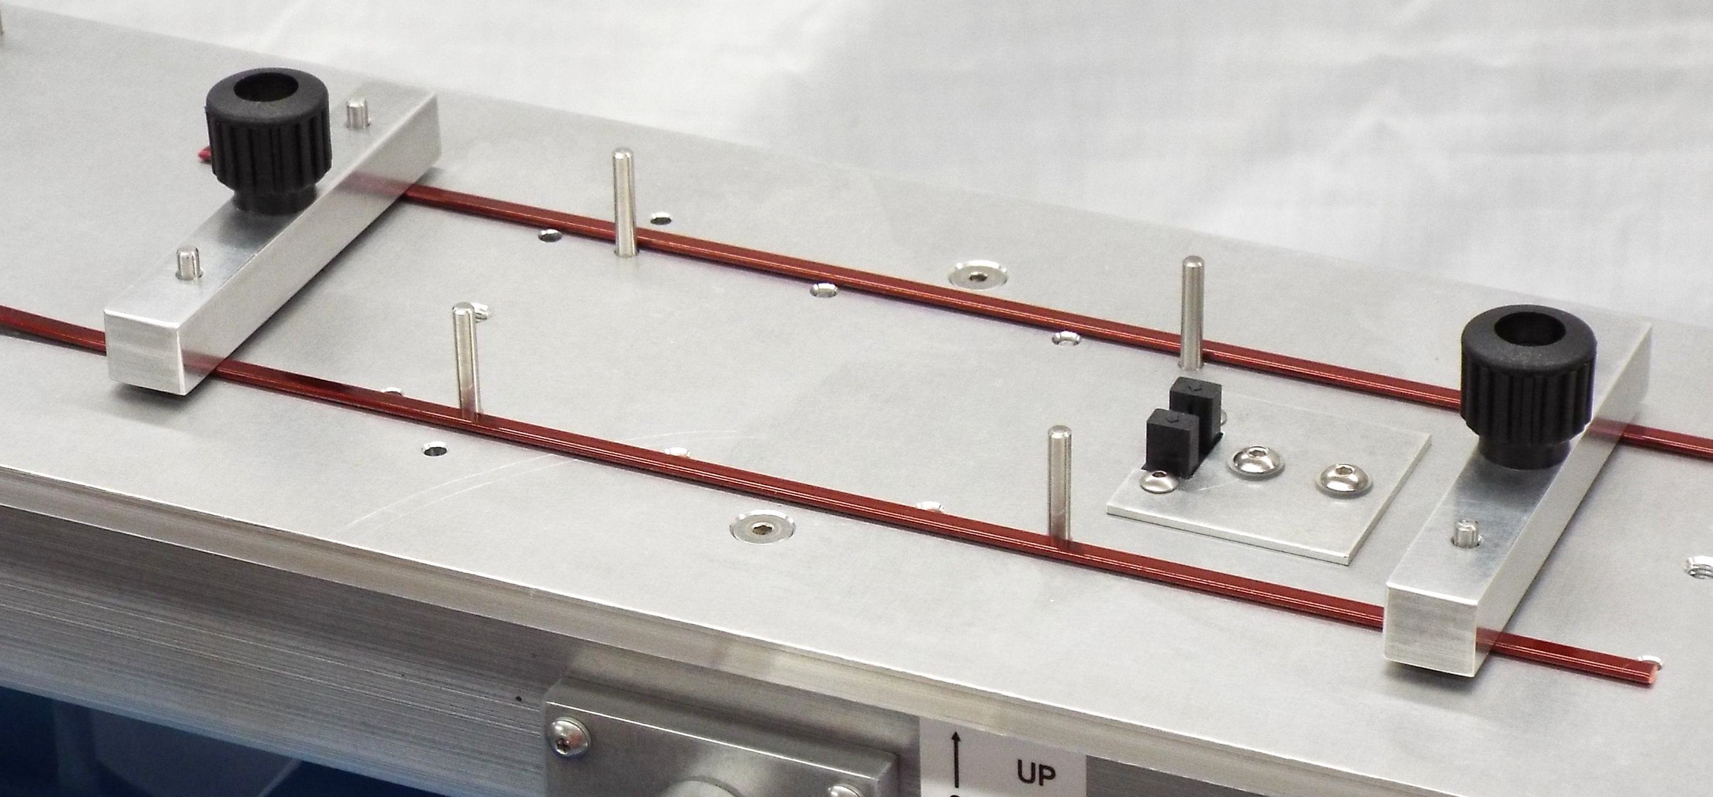

7” (18 cm)
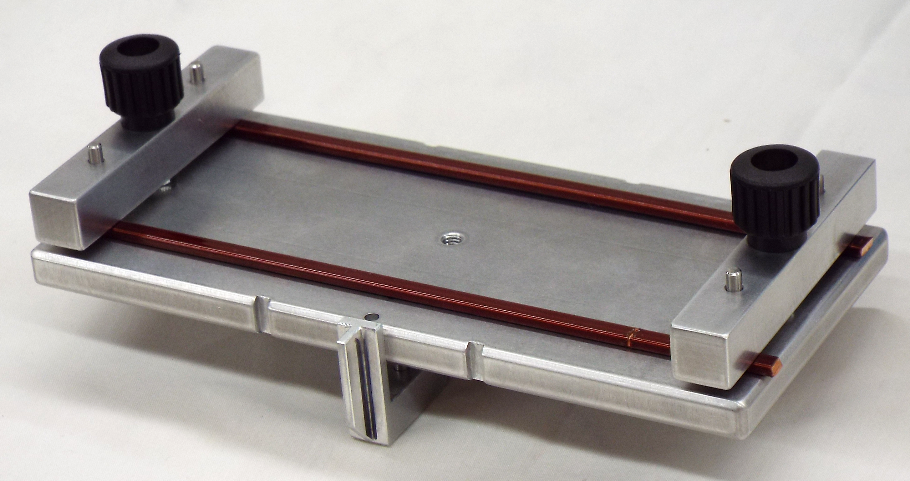

Figure 12
Figure 11

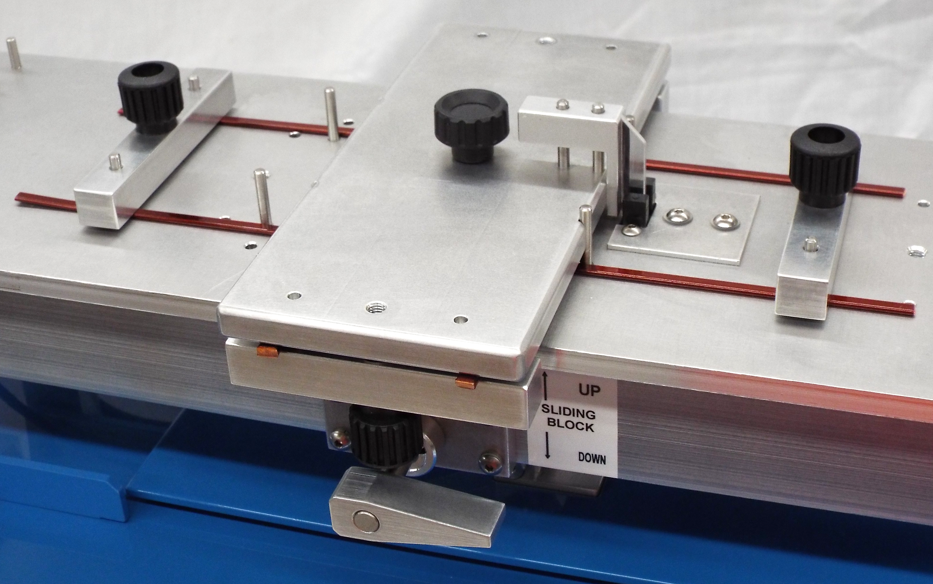
Adjust height of blade such that it is approximately 1/32” or 1 mm above the Test Bed

Figure 13

Make sure the Load Block support pins are in the down position.
The Load Block is gently placed (with the wire facing down) onto the surface of the wire on the Test Bed. Line up the Load Block with the Load Block Guide Pins to center the Load Block.
The Moving Block is now in place above the wires on the Test Bed.

Optional: Wire holding method for rectangular wires up to 6 x 20 mm rectangular
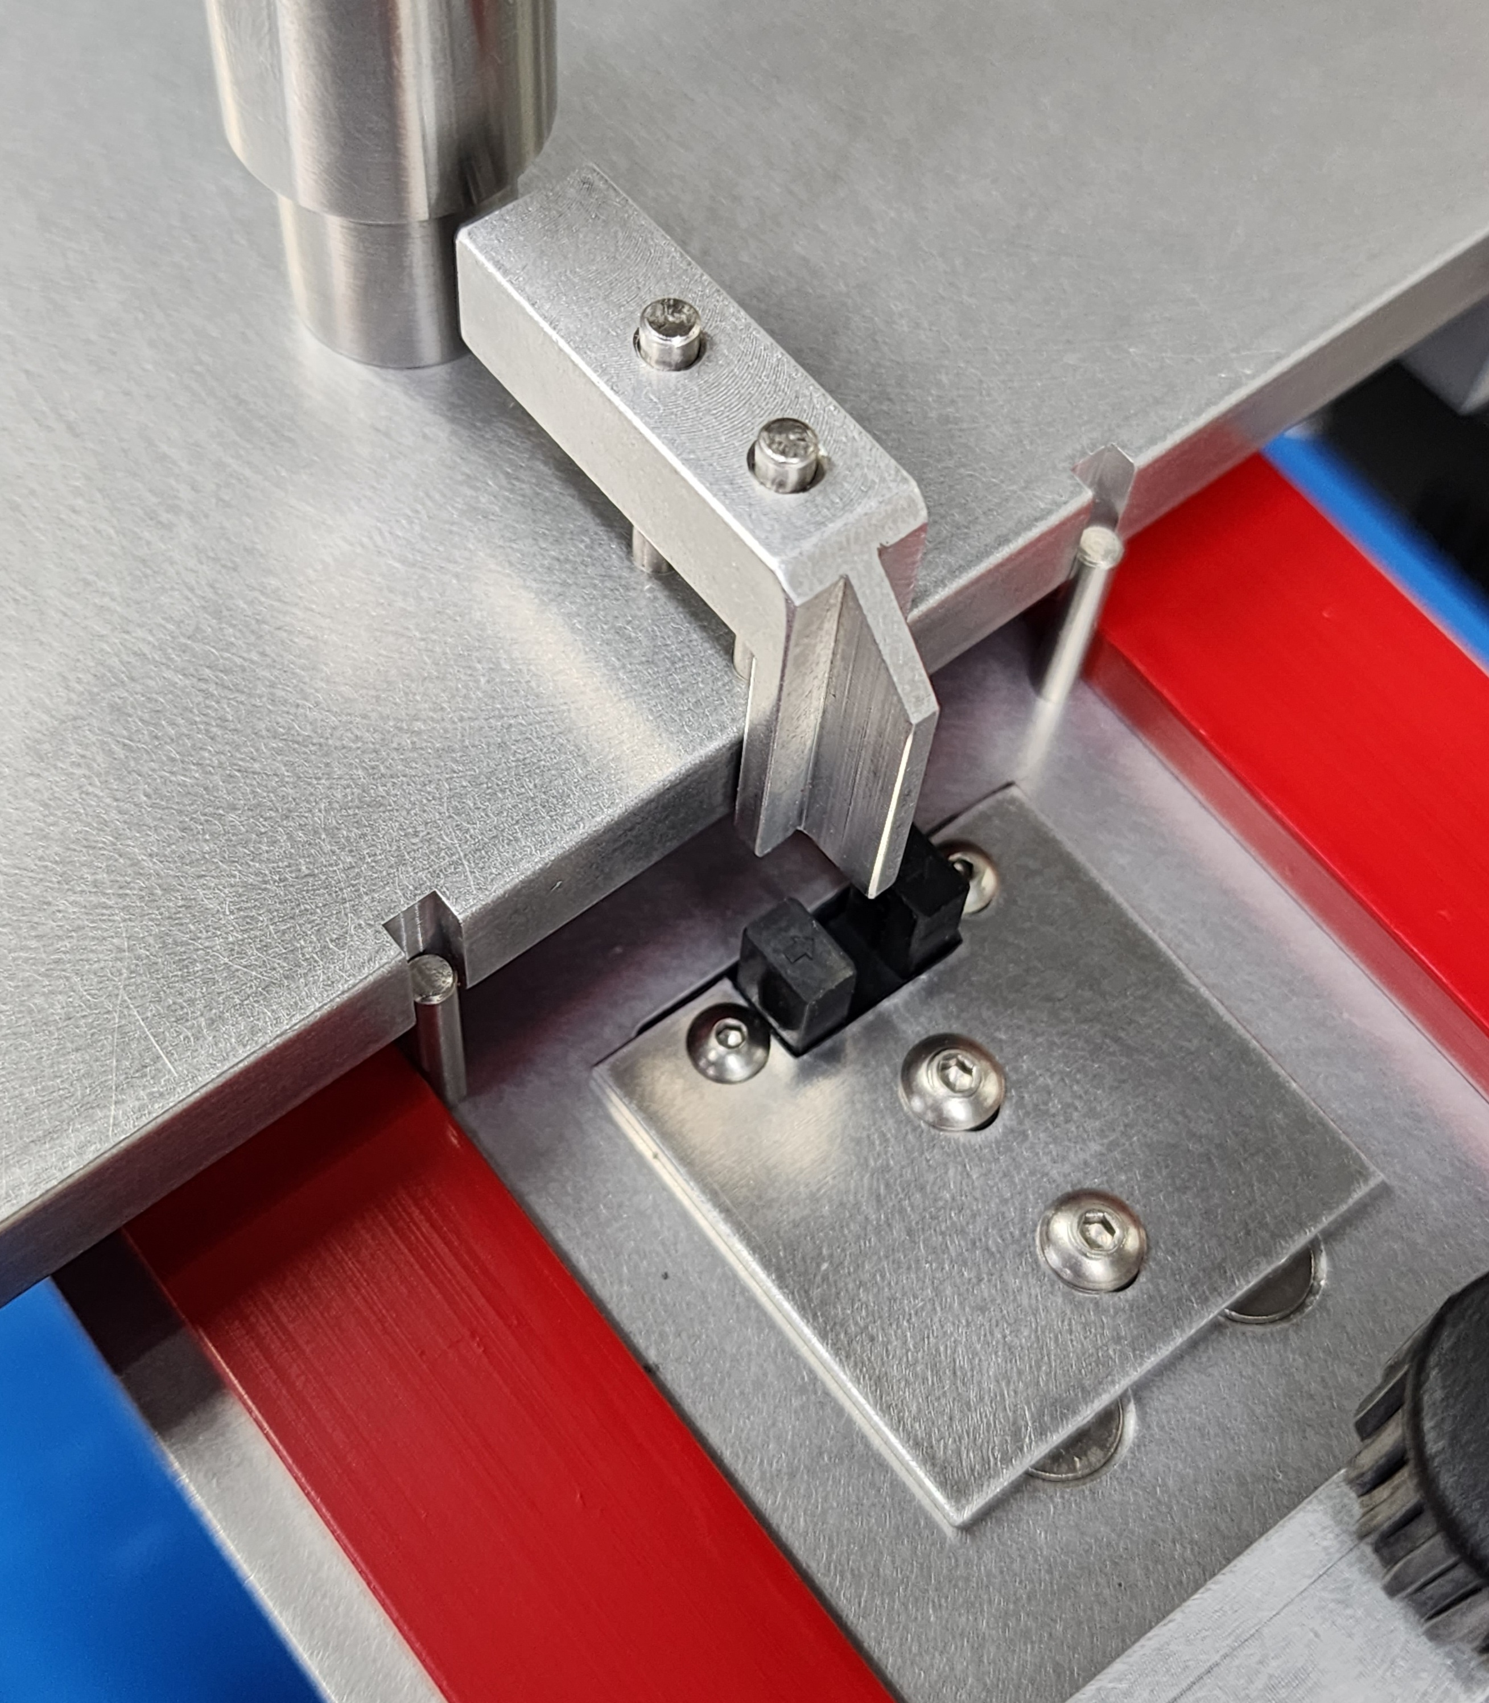
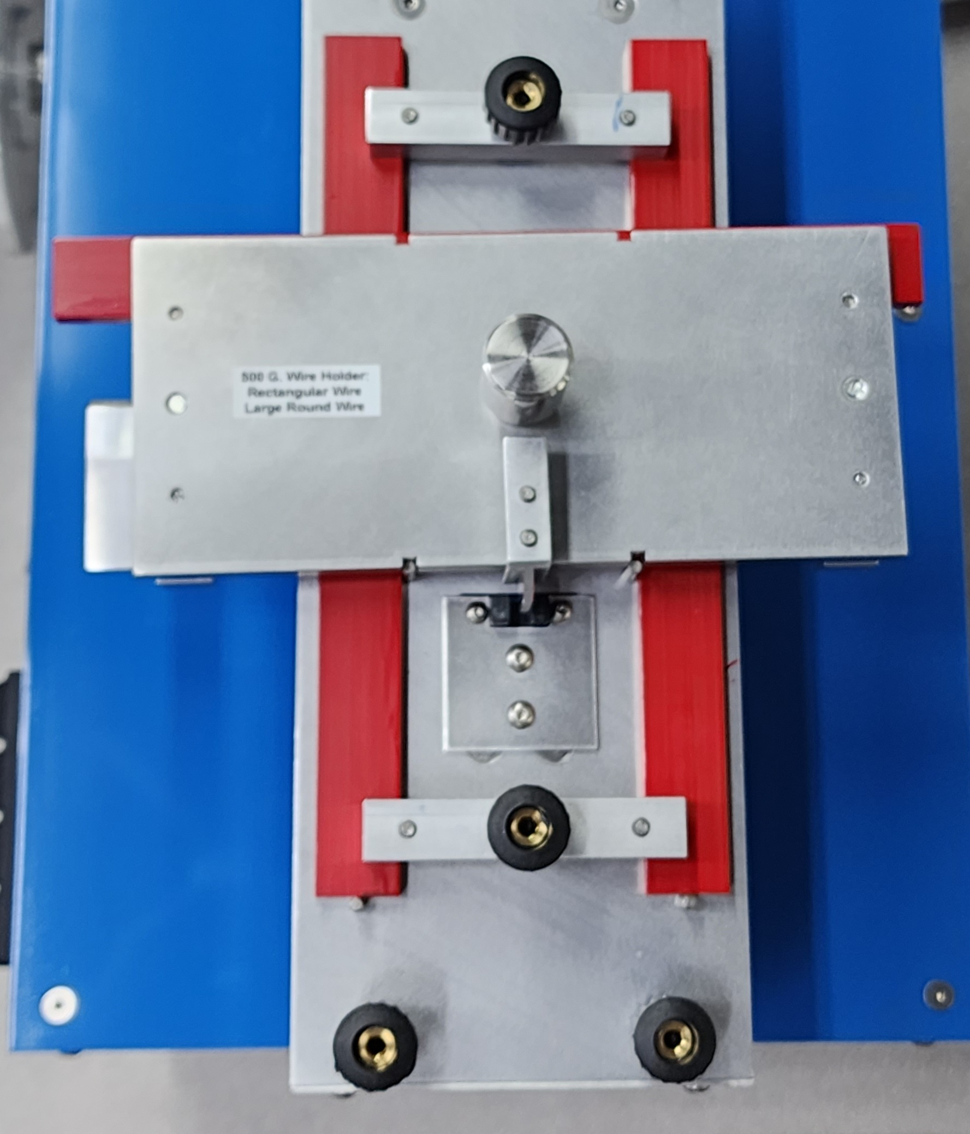
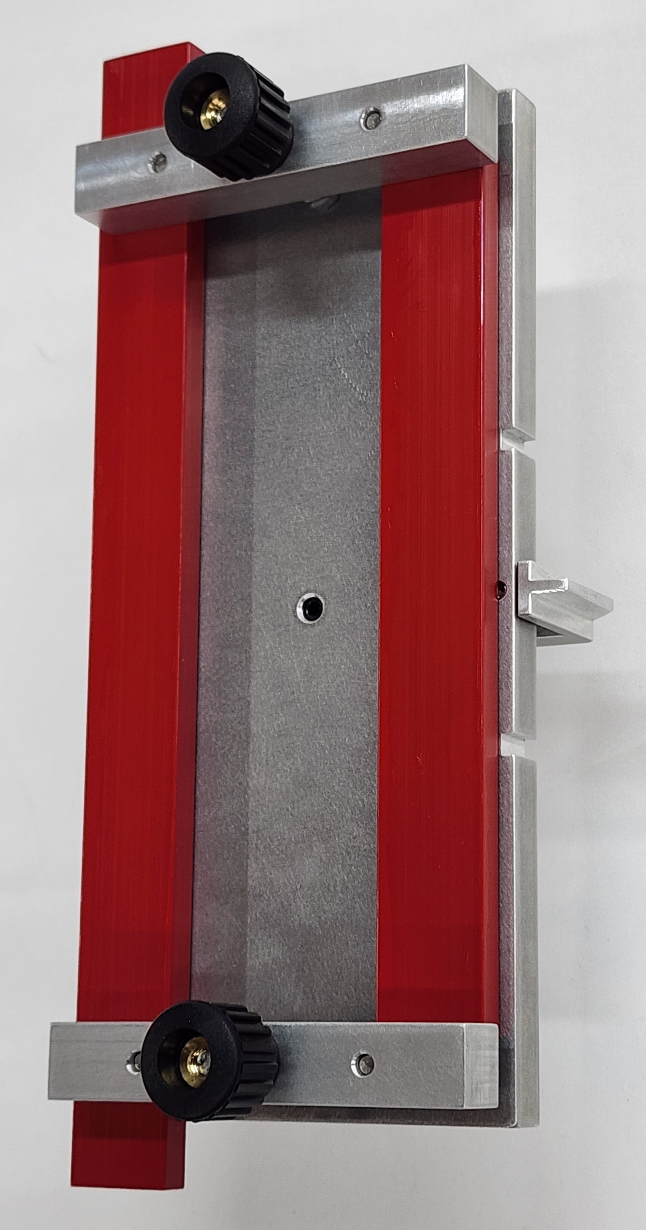
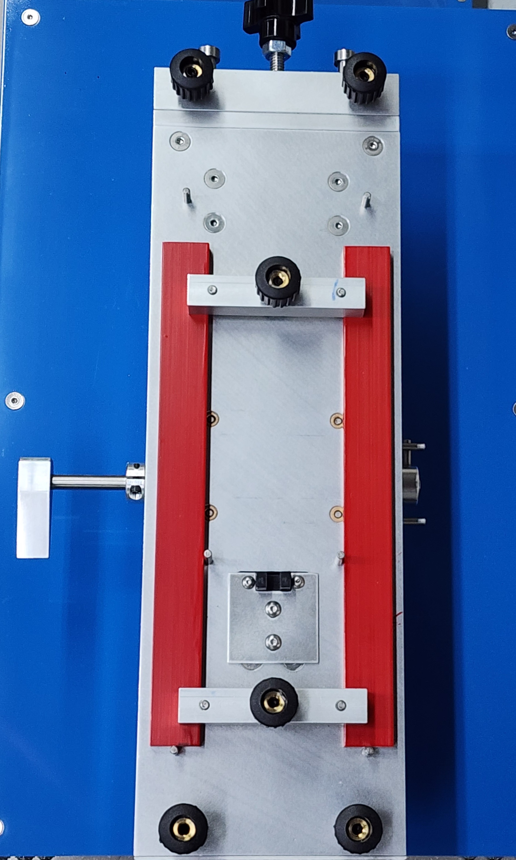

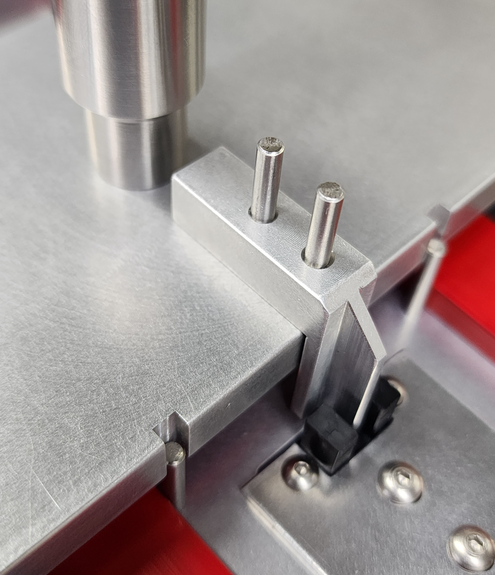

Push tab down.
Make sure the tab is not touching the platform.
Keep a space of approximately 1 mm

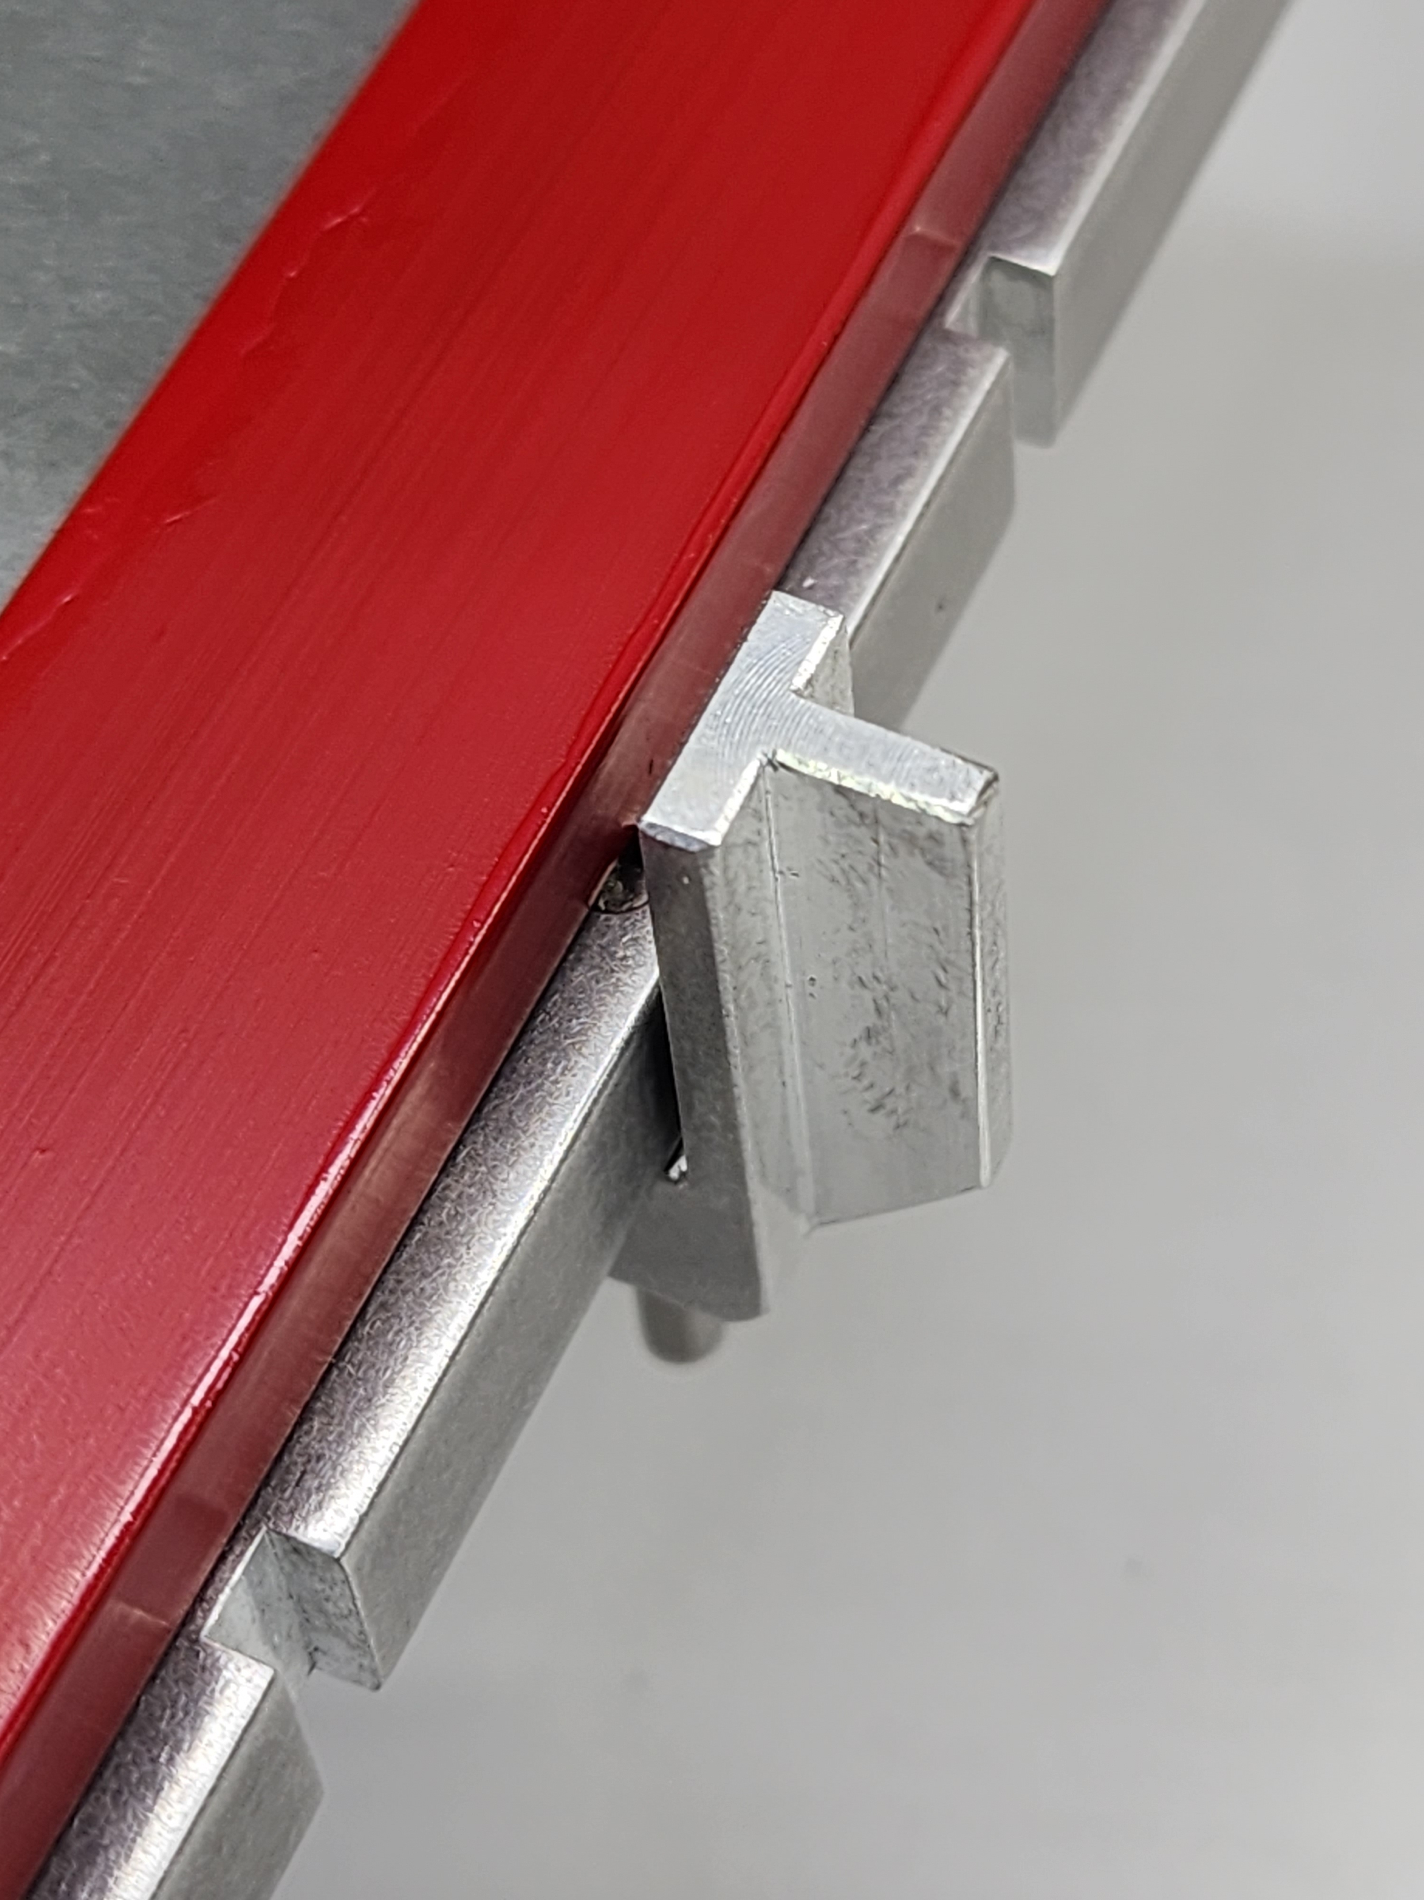
Place Load block over the test bed
14.6 cm
long wire

Oversized rectangular wires on
test bed and load block

Figure 14

4.0 Menu screen
Main Menu Exit

- Setup Menu

- Calibration menu

- Save Settings

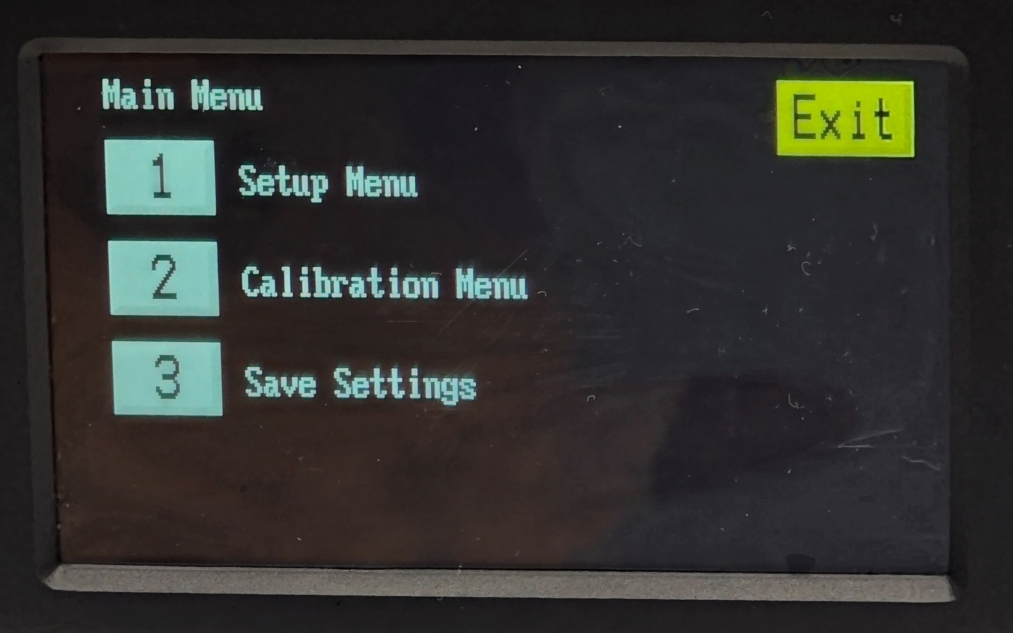
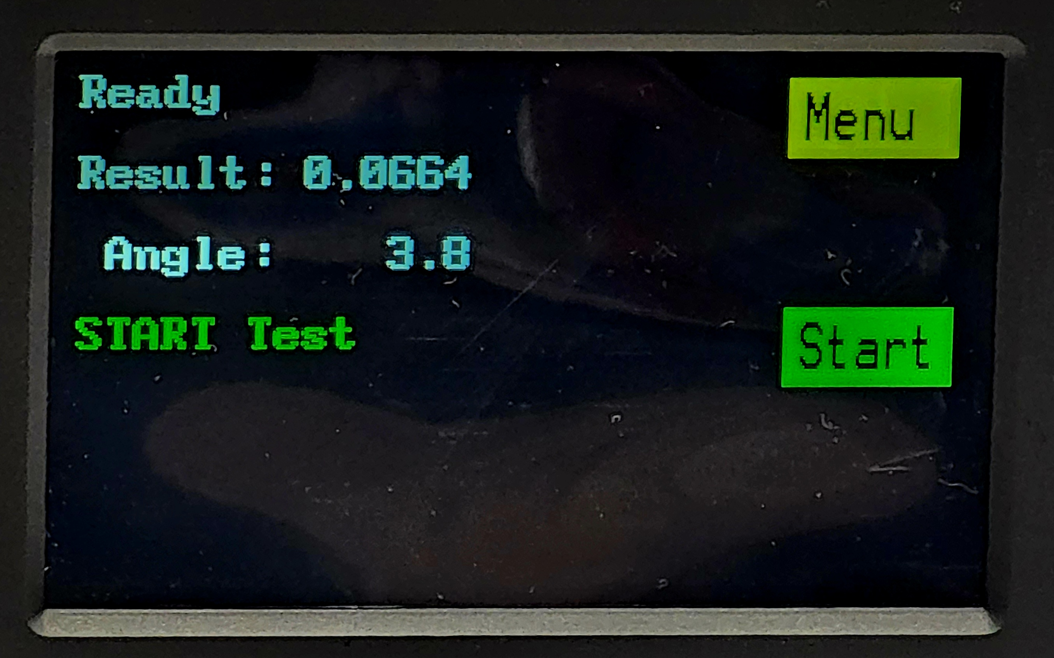
Press Menu key

1 Setup Menu
Set Brightness Exit

- Low
- Medium
3 High

1 Display Brightness
2 Turn Screen Saver Off
3 Turn WiFi Off
4 Non-Standard Speed
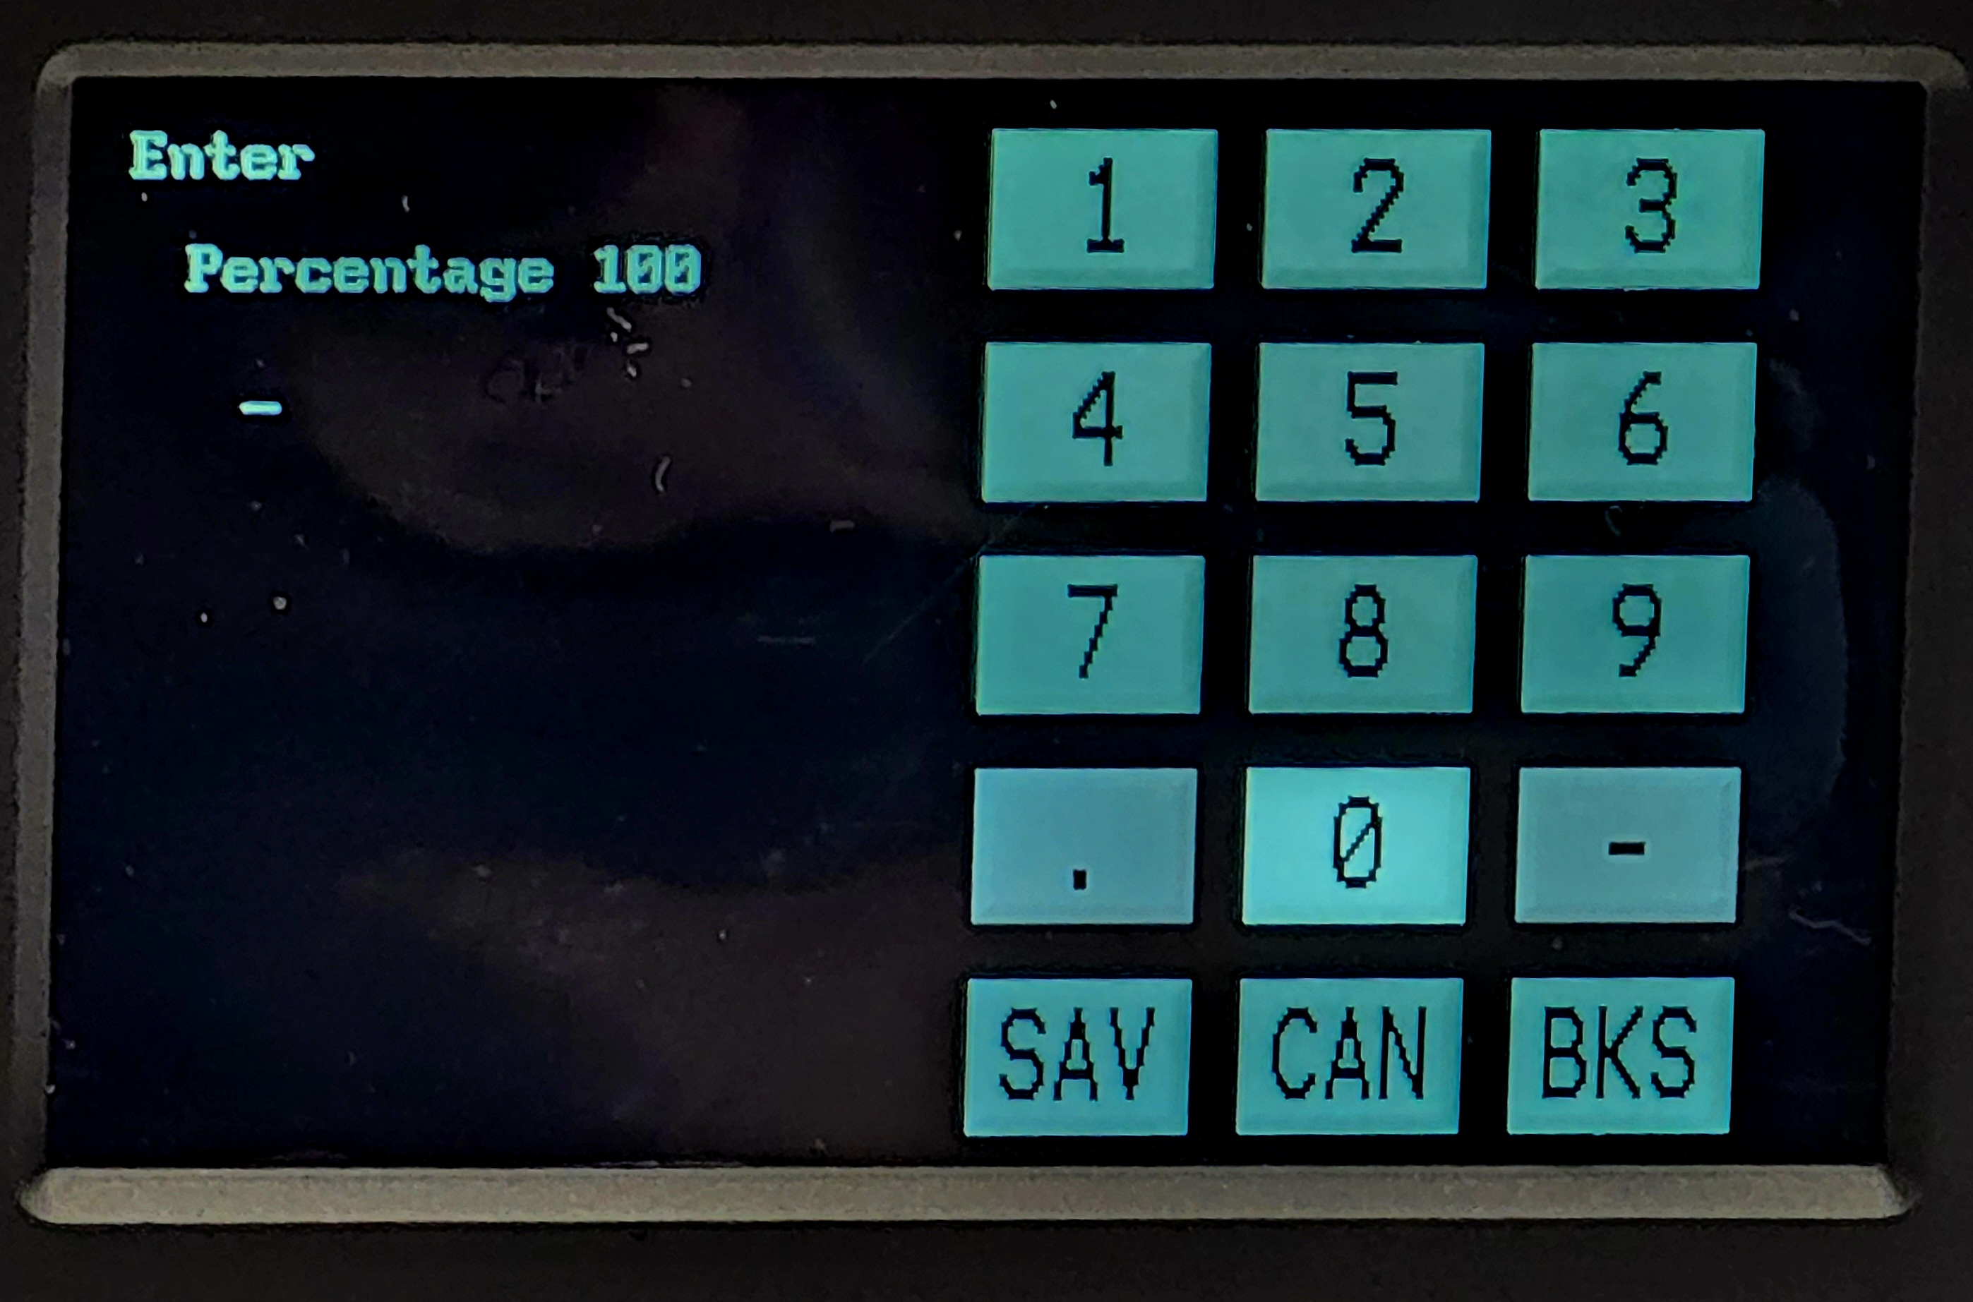

Percentage 100

100% of the standard speed of 1° per second.
Change this number lower, between 10 to 100 to get lower % of standard speed.

2 Calibration Menu
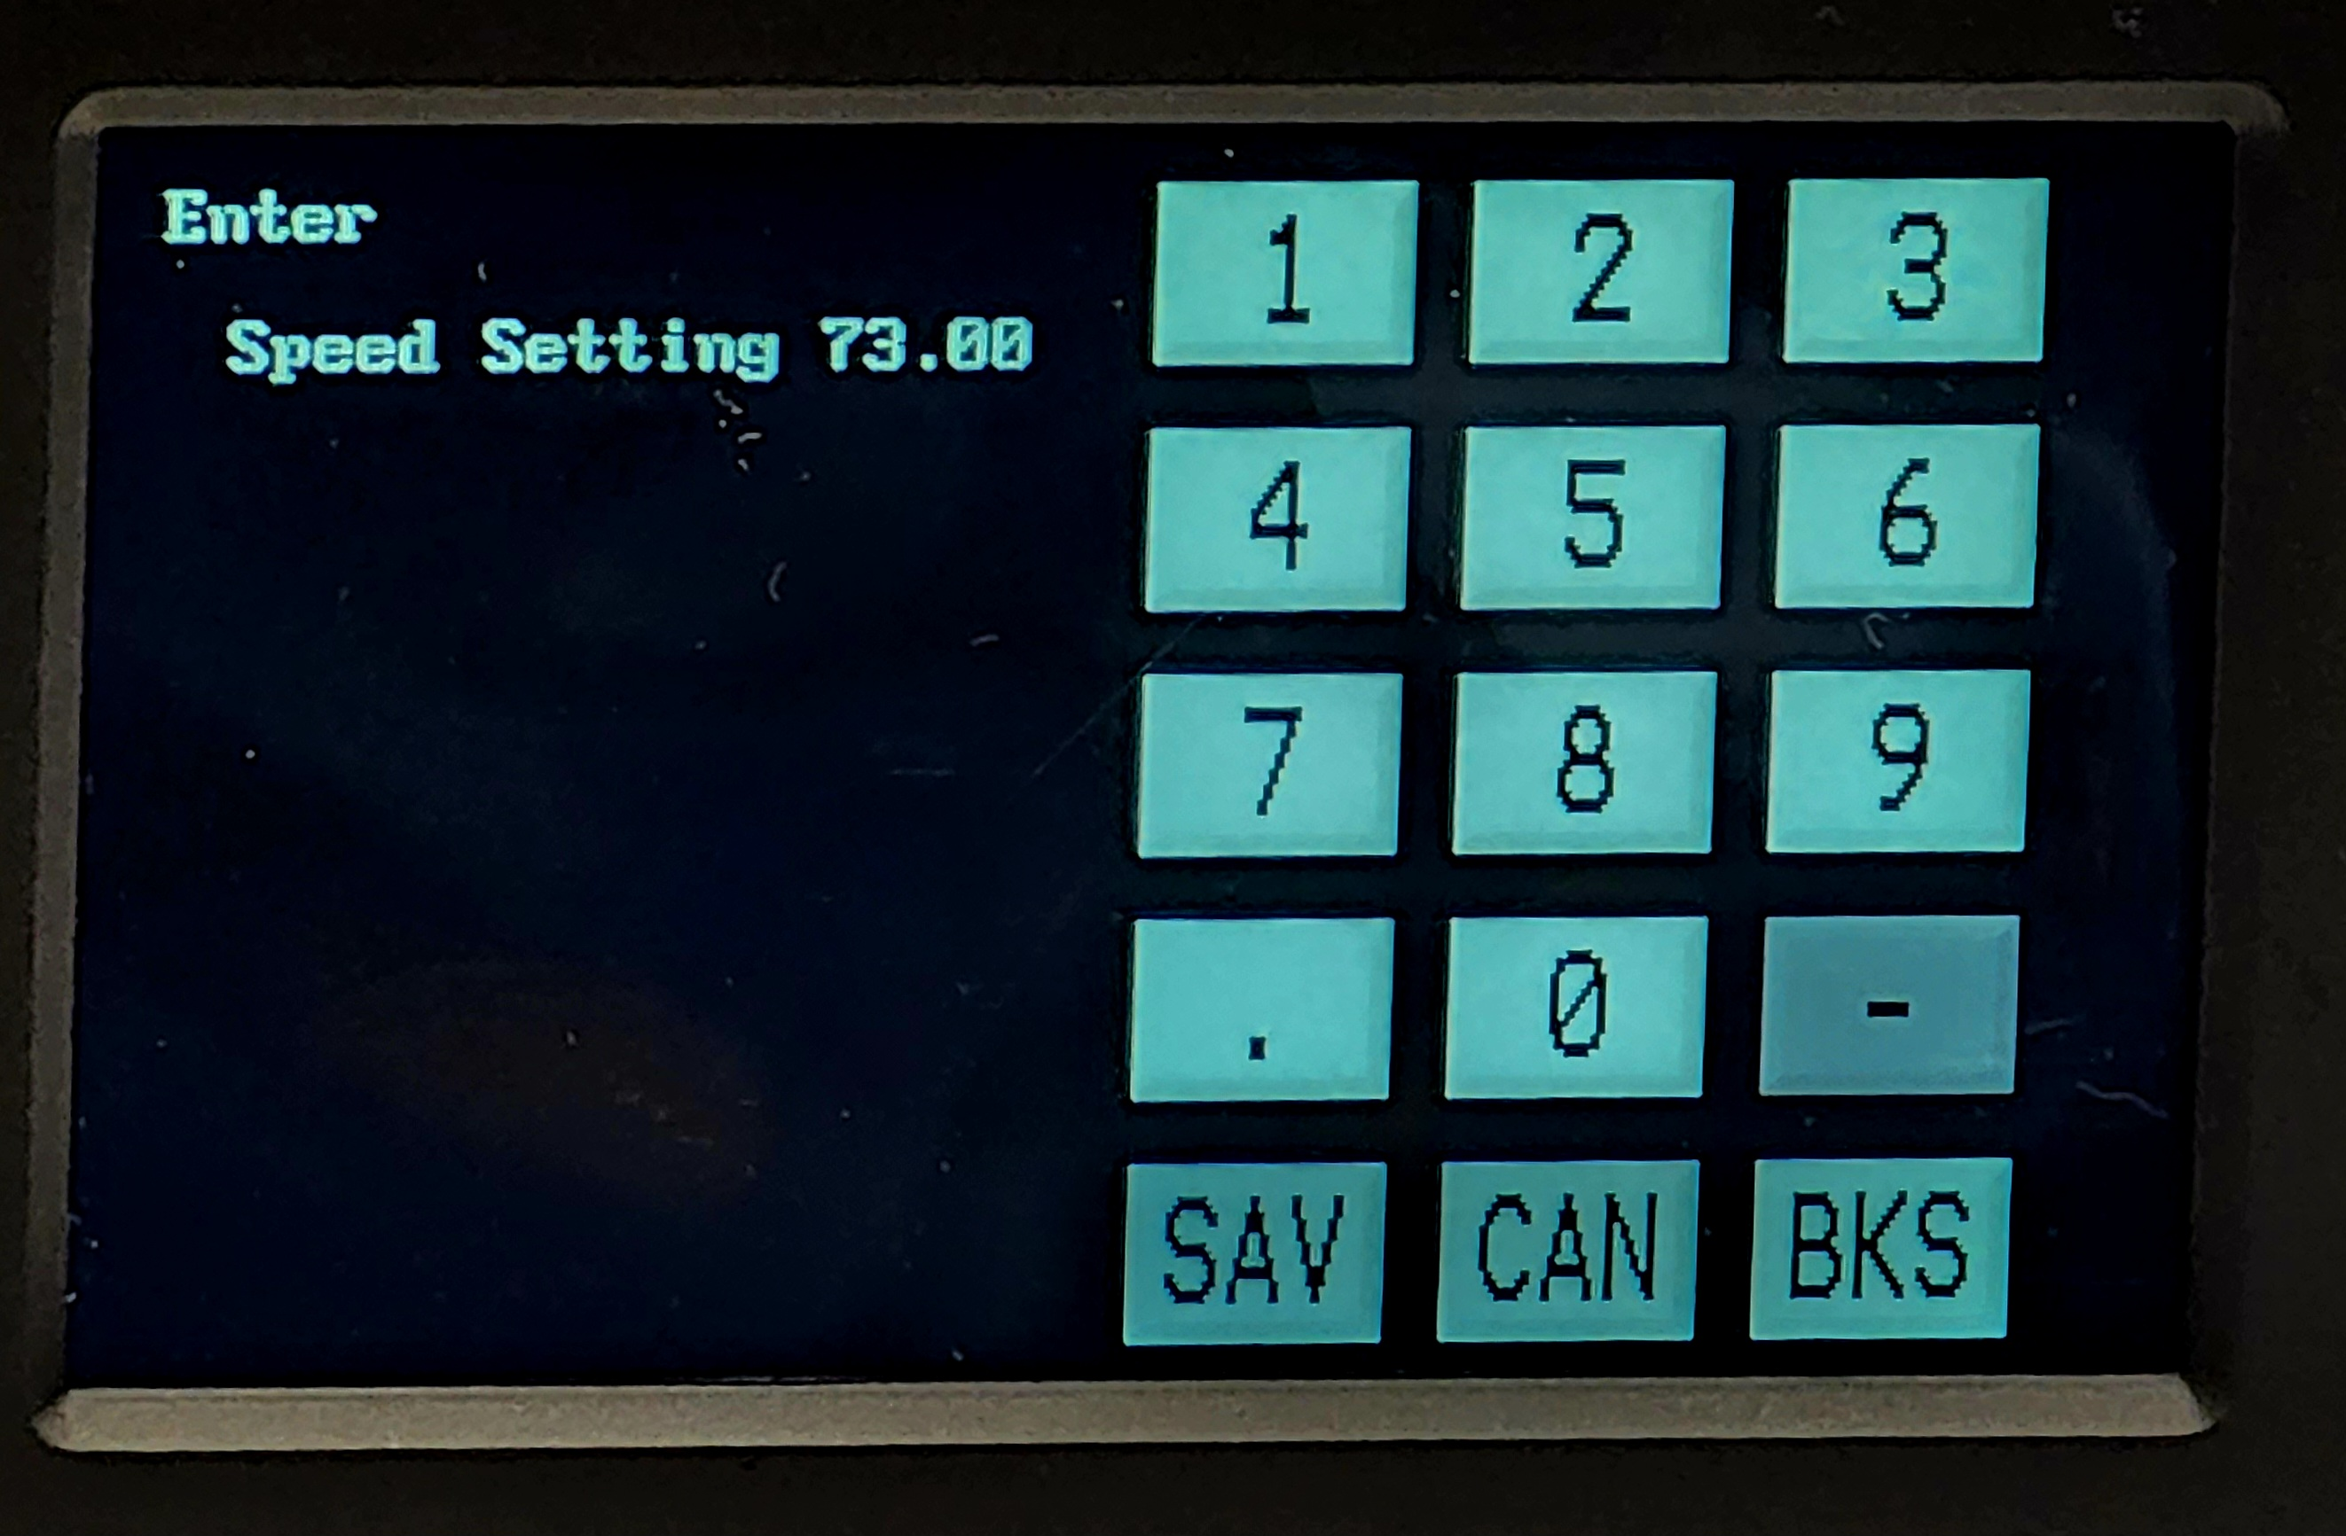
1 Adjust Speed
2 Adjust Angle Trim
3 Set Angle
4 Reset Plane

Enter
Angle Trim 1.0000

Enter
Speed setting 73.00
Change the number up to increase speed
Change the number down to decrease speed
Number can be change between 50 to 150

2 Calibration Menu
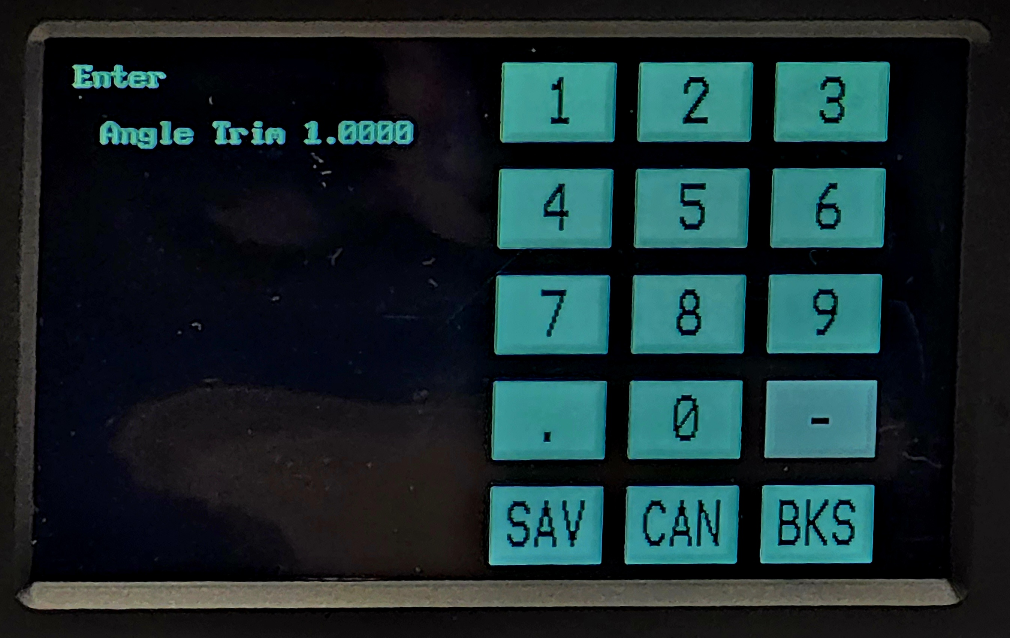
1 Adjust Speed
2 Adjust Angle Trim
3 Set Angle
4 Reset Plane

Enter
Angle trim 1.0000
This is for the fine adjustment of the display angle.
Change the number up or down to change the angle.
Number can be change between 0.75 to 1.25

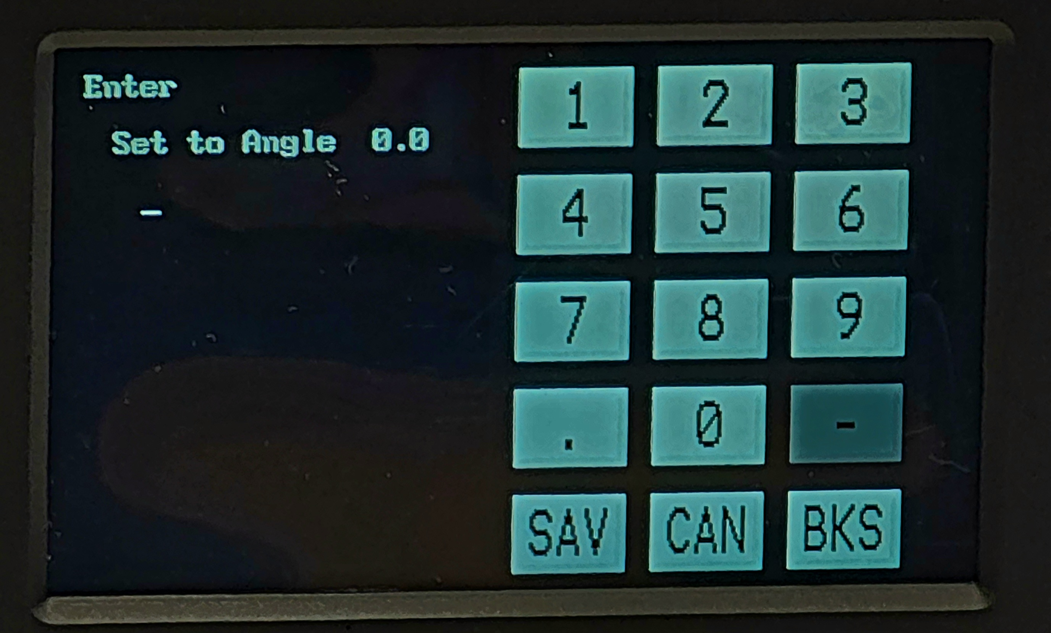
2 Calibration Menu
1 Adjust Speed
2 Adjust Angle Trim
3 Set Angle
4 Reset Plane

Enter
Set to Angle 0.0
For Calibration purpose
To set the angle for the incline plane platform to stop.
Enter the angle desired, 1° to 30°, and press Save.
The incline plane plate for will rise to the set angle.

Select 4 Reset Plane to reset the platform.

3 Save Settings - - Save the current settings

5.0 Calibration
Incline Plane
Note: Make sure the tester is leveled
The platform reset position (horizontal) is 0° +/- 0.5°
The maximum incline angle is 30° +/- 1°
The Incline Platform angle can be checked using a calibrated Inclinometer.

The Incline Plane Platform is set at the factory for a rate-of-rise of approximately 1°/second.
The rate-of-rise can be adjusted following the indication in the Calibration menu.

Load Blocks
The load blocks are manufactured to approximately 50 +/- 1 g. and 500 +/- 5 g.
Since the addition of wires, especially with larger wires, the total weight will change, and
from Physics principles, the load block weight is negated in the determination of the Static CoF value, the precise weight of the load block is not needed.
Therefore, it is not necessary to calibrate the Load Blocks

6.0 Maintenance
The Nova+ 923 requires minimal maintenance. Make sure the Incline Plane Platform/Chassis horizontal position are correctly leveled. Adjust the support feet to level the chassis.
For the Static Friction Test Assembly, keep the Test Bed and Moving Block free of dust and other contaminants. Make sure there are no damages such as scratches to the surface of the Test Bed and Moving Block. The Test Bed pivot can be lubricated as needed.
It is important and good practice to keep the Nova+ 923 clean and free from dust and dirt. Clean the equipment surface with window glass cleaner or mild detergent.
Make sure the chassis is level.
Warning: Do not use solvent to clean the painted surface and LCD Display bezel (cover)

6.0 Parts List
User Replaceable Parts:
- Power Entry: 1 Amp for 110 VAC or 1 Amp for 240 V ac. (Main Power Fuse)
- Static CoF Load Block:
N923-LB-50g (50 grams load block)
N923-LB-500g (500 grams load block)
N923-LB-500g-RW (500 grams load block for large round and rectangular wire)

Note: for other components and modules, contact Ampac International, Inc. at
ampac-intl@msn.com

Appendix A
WR-100 Wireless Receiver:

WR-100 Wireless Receiver and data collection software

The WR100 Wireless Receiver provides a standalone network that does not connect to other networks. Its job is to listen for Ampac units and collect data when they have it. The data is passed through a USB cable to an application running on a Windows PC or any other PC that can take serial data from it.

The Windows application, Data Hub, can be downloaded through the internet.
The latest version will always be available at:
https://ampac-intl.com/ampachub/Data_Hub.exe for download.

The receiver hardware receives the test data and Data_Hub separates it into files based on the unit type. Each record in the file contains date, time, unit serial number, an identifying text string, and the data each unit sends, the results and sometimes other parameters.
This application can also do queries that will produce text files that can be used for analysis, etc. without interfering with ongoing data capture.

All WR-100's ship with a host name of AMPACHUB and password of 12345678. They can be left this way or changed to another host name or password by Using the Data Hub program. For instance, if there are more than one in the vicinity.
1. Make sure the Data_Hub software is connected via serial port connection to the WR100 unit
2. Type cmd id on the bottom editor line and press send. The WR100 should send back it's ID.
3. Type cmd newname to see the current host name.
4. Type cmd newname and the name you want to change it to if you want to change it.
Each item separated by spaces like: cmd newname HUB2
5. Type cmd newpass to see the current password and change it in the same manner.
6. These are the name and password used by your testers to access the WR100 so if you
change them, you will need to change them in your testers as well using Bluetooth.
Names and passwords are case sensitive. Type them as you wish for them to appear.

The WR100's do not use Bluetooth for updates since they have a serial interface to use.
Enter the UPDATE command with parameters as explained earlier.
- The command UPDATE name,password,url
(format as shown with commas and a space after UPDATE)
b. Your local Wireless network name like: AmpacGuest
c. Your local Wireless network password like: ampACgUest (usually must be exact)
d. The URL on ampac-intl.com from the root like: /updates/wr100v201.bin
e. They can be on other domains if you include the http://domainname.com/updates/file.bin
f. So, it might look like: update AmpacGuest,ampACgUest,/updates/wr100v201.bin

